St. Paul’s RC Academy

School Improvement Report
Session 2024-2025
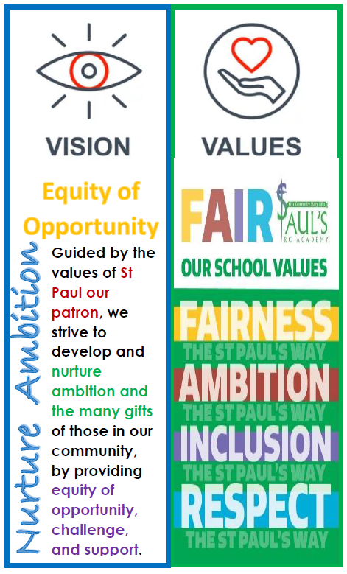

St. Paul’s RC Academy,
90 Gillburn Road
Dundee. DD3 0EH
Tel 01382 307701
Email: st-pauls@dundeecity.gov.uk

This document shares and celebrates the improvements in our School and embraces all ages and stages. It is based upon our School Improvement Plan for session 2024-25


Our School Vision
Guided by the values of St Paul our patron, we strive to develop and nurture ambition, and the many gifts of those in our community, by providing equity of opportunity, challenge and support.
Our School Values

FAIR Fairness - Ambition - Inclusion - Respect FAIR

Our Aims:

1 Learning and Teaching
To create a learning culture of the highest aspirations and motivation where all young people are engaged and challenged to achieve their full potential. In every classroom, dynamic, varied teaching and learning allows pupils to become successful learners, confident Individuals, responsible citizens and effective contributors to society.

2 Ethos and Life of our School
To ensure that our Gospel Values are embedded throughout our community and that we work and learn together in a safe, secure and happy environment, setting high expectations for all where our young people will thrive.

3 Personal Support
To nurture individuality and uniqueness in all members of the St Pauls community. To provide the highest level of support we will work closely with other professionals and continue to extend our partnerships to ensure all our Young People are given equal opportunities to maximise their potential.

4 Assessment, Attainment and Achievement
The staff at St Pauls will ensure that pupils are supported in their learning journey by giving them a clear picture of what they should learn, share criteria for success in every lesson and encourage engagement in opportunities for wider achievement.

5 Professionalism and Professional Development
We are committed to self-evaluation to identify ways that we can improve our professional skills and knowledge through Career Long Professional Learning to the benefit of our young people.

6 Working with Partners
To develop high quality partnerships to enable our curriculum to offer the widest possible range of academic and vocational courses to ensure all our Young People are given equal opportunities to maximise their potential and the appropriate support to enhance learning and teaching.

Context of the School:

St Paul’s RC Academy opened in 2008 following the merger of Lawside RC Academy and St Saviour’s RC High School. As a result, the catchment area for St Paul’s is vast, spanning from Broughty Ferry to Ardler and St. Mary’s, and beyond to Denhead of Gray, covering all areas North of the Kingsway. The school roll has been increasing over the last few years and there are currently 1082 young people in our school community. All young people work through the Broad General Education in S1 – S3, moving on to the Senior Phase in S4 – S6. The curriculum offers our young people some personalisation and choice in a wide range of subjects, at various levels, leading to certification and a positive destination. There are many and varied opportunities for extra-curricular activities and wider achievement, often leading to additional qualifications. The school have many partners involved in providing support, learning experiences and wider opportunities to our pupils. Working with our parents is a priority and we communicate daily through the Parent Padlet, Twitter, the school website or Group Call,
Data reflecting our pupil attainment for the session 2024 - 2025

S3 Curriculum for Excellence

BGE Attainment Data 2020- 2021 (National Measure - percentages of S3 pupils achieving level 3 or better)

 | Reading | Writing | Talking & Listening | Numeracy
S3 (CFE Third Level) | 79% | 79% | 80% | 80%

From the figures above, 53% achieved Level 4 in Reading, 52% in Writing, 60% in Talking & Listening, and 49% achieved Level 4 in Numeracy.

BGE Attainment Data 2021- 2022 (National Measure - percentages of S3 pupils achieving level 3 or better)

 | Reading | Writing | Talking & Listening | Numeracy
S3 (CFE Third Level) | 85% | 80% | 86% | 77%

From the figures above, 54% achieved level 4 in Reading, 53% in writing, 55% in Talking and Listening, and 45% achieved level 4 in Numeracy.

BGE Attainment Data 2022- 2023 (National Measure - percentages of S3 pupils achieving level 3 or better)
 | Reading | Writing | Talking & Listening | Numeracy
S3 (CFE Third Level) | 77% | 77% | 77% | 75%

From the figures above, 49% achieved level 4 in Reading, 49% in writing, 49% in Talking and Listening, and 39% achieved level 4 in Numeracy.

BGE Attainment Data 2023- 2024 (National Measure - percentages of S3 pupils achieving level 3 or better)
 | Reading | Writing | Talking & Listening | Numeracy
S3 (CFE Third Level) | 70% | 76% | 78% | 75%

From the figures above, 37% achieved level 4 in Reading, 45% in writing, 46% in Talking and Listening, and 55% achieved level 4 in Numeracy.

BGE Attainment Data 2024- 2025 (National Measure - percentages of S3 pupils achieving level 3 or better)
 | Reading | Writing | Talking & Listening | Numeracy
S3 (CFE Third Level) | 70% | 70% | 70% | 81%

From the figures above, 35% achieved level 4 in Reading, 36 % in writing, 35 % in Talking and Listening, and 37% achieved level 4 in Numeracy.

Senior Phase Attainment Data

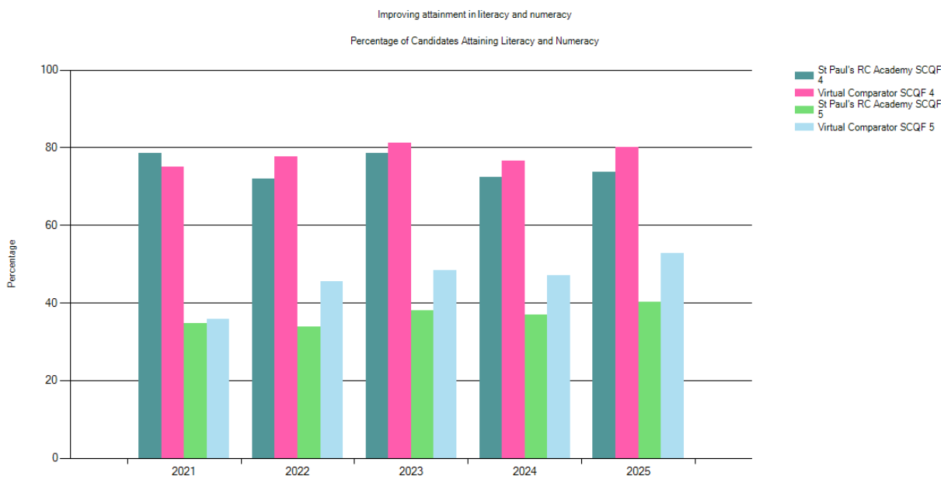
Local Benchmarking Measure: Literacy and Numeracy by SCQF Level (S4)
DisplayName | Year | % Level 4 Literacy and Numeracy | % Level 5 Literacy and Numeracy | Number in Cohort
St Paul's RC Academy | 2025 | 73.71 | 40.21 | 194
Virtual Comparator | 2025 | 80.15 | 52.73 | 1940
St Paul's RC Academy | 2024 | 72.40 | 36.98 | 192
Virtual Comparator | 2024 | 76.30 | 46.35 | 1920
St Paul's RC Academy | 2023 | 78.46 | 37.95 | 195
Virtual Comparator | 2023 | 81.44 | 48.31 | 1950
St Paul's RC Academy | 2022 | 72.02 | 33.93 | 180
Virtual Comparator | 2022 | 77.68 | 45.83 | 1800
St Paul's RC Academy | 2021 | 78.61 | 34.76 | 155
Virtual Comparator | 2021 | 74.81 | 36.04 | 1550
St Paul's RC Academy | 2020 | 80.00 | 52.94 | 170
Virtual Comparator | 2020 | 76.94 | 41.24 | 1700

What does this mean?
This means that our young people in S4 have improved on both their combined Literacy and Numeracy qualifications since last year. However, our virtual comparator school estimates where a school with all of our contexts should be. There is room for improvement here.
What will we do now to improve?
Focused tracking on targeted groups to ensure that all young people have an opportunity to receive a Numeracy and Literacy through their National Qualifications in English and Maths and develop their talent and abilities to the full (Article 29 UNCRC).
Local Benchmarking Measure: Literacy and Numeracy by SCQF Level (S5)
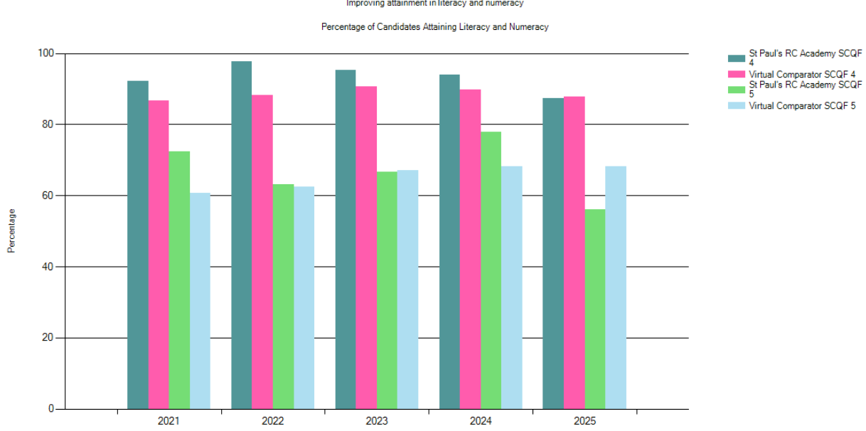
DisplayName | Year | % Level 4 Literacy and Numeracy | % Level 5 Literacy and Numeracy | Number in Cohort
St Paul's RC Academy | 2025 | 87.23 | 56.03 | 141
Virtual Comparator | 2025 | 87.27 | 68.23 | 1410
St Paul's RC Academy | 2024 | 93.89 | 77.86 | 131
Virtual Comparator | 2024 | 90.08 | 69.16 | 1310
St Paul's RC Academy | 2023 | 95.37 | 66.67 | 108
Virtual Comparator | 2023 | 90.56 | 66.85 | 1080
St Paul's RC Academy | 2022 | 97.74 | 63.16 | 133
Virtual Comparator | 2022 | 88.12 | 62.33 | 1330
St Paul's RC Academy | 2021 | 92.13 | 72.44 | 127
Virtual Comparator | 2021 | 87.09 | 60.24 | 1270
St Paul's RC Academy | 2020 | 94.00 | 69.00 | 100
Virtual Comparator | 2020 | 85.90 | 56.30 | 1000

What does this mean?
This means that our young people in S5 have attained Level 4 in line with our Virtual Comparator combined Literacy and Numeracy qualifications since last year. However, we have dropped in our Level 5 Literacy and Numeracy and we have larger numbers staying on to achieve more qualifications.
What will we do now to improve?
Ensure that returning S5 Pupils have Literacy and Numeracy Qualifications from S4. Continue to promote other pathways to achieve Level 5 via Application of Maths and Personal Finance Level 5 as an alternative to National 5 Maths keeping mind what is in the best interests of the child (Article 3 UNCRC). Similar approach for Literacy via English Nat 5 qualifications and Travel & Tourism Level 5.

Local Benchmarking Measure: Literacy and Numeracy by SCQF Level (S6)
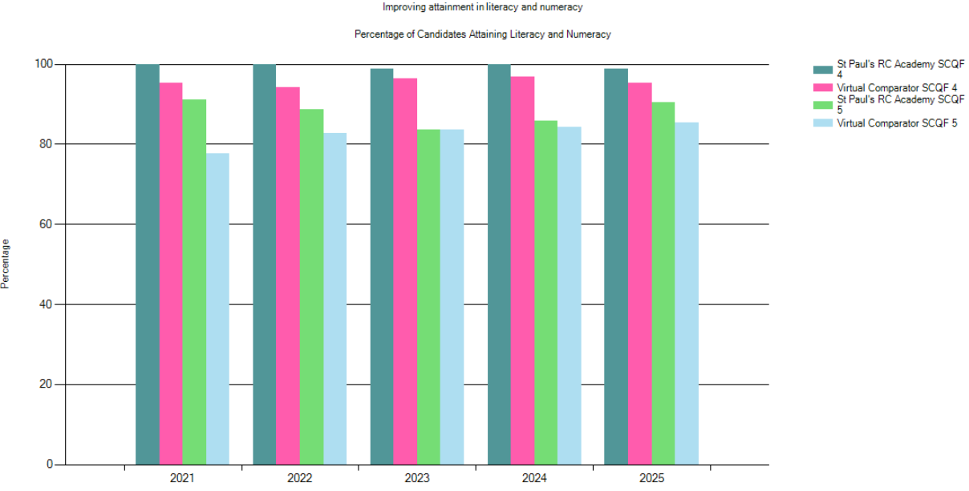
DisplayName | Year | % Level 4 Literacy and Numeracy | % Level 5 Literacy and Numeracy | Number in Cohort
St Paul's RC Academy | 2025 | 98.80 | 90.36 | 83
Virtual Comparator | 2025 | 95.30 | 85.30 | 830
St Paul's RC Academy | 2024 | 100 | 85.71 | 70
Virtual Comparator | 2024 | 96.57 | 84.29 | 700
St Paul's RC Academy | 2023 | 98.73 | 83.54 | 79
Virtual Comparator | 2023 | 96.33 | 83.42 | 790
St Paul's RC Academy | 2022 | 100 | 88.73 | 71
Virtual Comparator | 2022 | 94.23 | 82.68 | 710
St Paul's RC Academy | 2021 | 100 | 91.07 | 56
Virtual Comparator | 2021 | 95.18 | 77.68 | 560
St Paul's RC Academy | 2020 | 100 | 86.49 | 74
Virtual Comparator | 2020 | 95.54 | 78.38 | 740

What does this mean?
This means that our young people in S6 have attained greater results in Level 4 and Level 5 than in comparison with our Virtual Comparator combined Literacy and Numeracy qualifications consistently since 2020. We have more young people staying on than ever before for S6 and making good use of the various pathways to achieve this.
What will we do now to improve?
Ensure that the success of works well for our returning S6 pupils can be replicated for those returning earlier in S5. This can be done by looking at developing their skills in the BGE and making use of the additional Numeracy L4 and L5 Qualification for all learners. We are also utilising our Outreach Teacher and Inclusion Hub to help those achieve who are struggling to attend to ensure we are considering the Rights of the Child to an Education (Article 28 UNCRC).
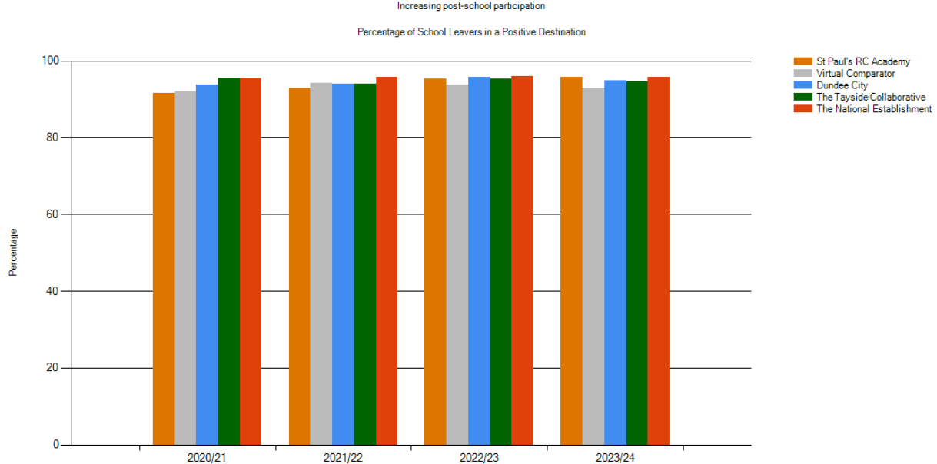
National Benchmarking Measure: Leaver Initial Destinations

Establishment | Year | % of Schools Leavers in a Positive Destination | Number in Cohort
St Paul's RC Academy | 2023/24 | 95.76 | 165
Virtual Comparator | 2023/24 | 93.15 | 1650
Dundee City | 2023/24 | 94.76 | 1431
The National Establishment | 2023/24 | 95.71 | 55961
St Paul's RC Academy | 2022/23 | 95.27 | 169
Virtual Comparator | 2022/23 | 93.67 | 1690
Dundee City | 2022/23 | 95.56 | 1441
The National Establishment | 2022/23 | 95.87 | 54719
St Paul's RC Academy | 2021/22 | 92.78 | 180
Virtual Comparator | 2021/22 | 94.11 | 1800
Dundee City | 2021/22 | 93.9 | 1394
The National Establishment | 2021/22 | 95.74 | 55211
St Paul's RC Academy | 2020/21 | 91.61 | 155
Virtual Comparator | 2020/21 | 91.87 | 1550
Dundee City | 2020/21 | 93.7 | 1223
The National Establishment | 2020/21 | 95.48 | 50719

What does this mean?
This means that almost all of our young people who leave school do so with an identified positive destination to move on to such as Further Education, Higher Education, Employment or Training/Volunteering. It also shows that our young people get an amazing service and support here from the school, having higher numbers of pupils than our Virtual Comparator, Dundee City and the National figures.
What will we do now to improve?
Our school Core Implementation group will continue to highlight young people from S3 who may potentially be at risk of leaving school without a positive destination to move on to. Together with our partners from Skills Development Scotland and Employability we will create pathways for success. (Article 6 UNCRC)

Local Benchmarking Measure: Improving Attainment for All (S4)

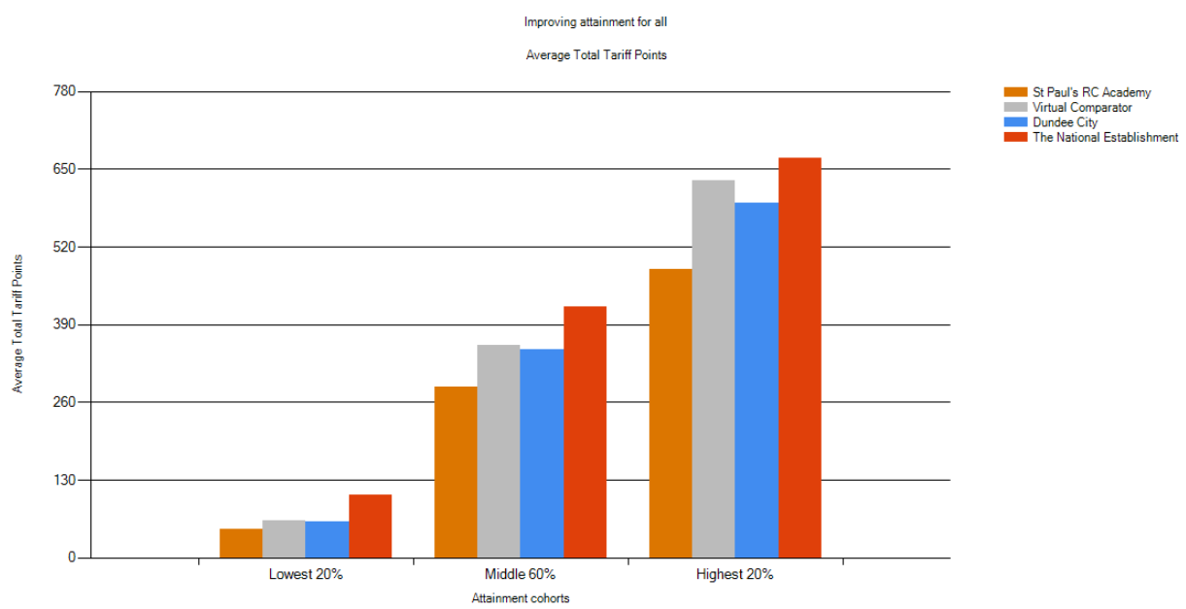

Establishment | Year | Lowest 20% | Middle 60% | Highest 20% | Number in Cohort
St Paul's RC Academy | 2025 | 47 | 286 | 483 | 194
Virtual Comparator | 2025 | 62 | 355 | 632 | 1920
Dundee City | 2025 | 60 | 349 | 592 | 1556
St Paul's RC Academy | 2024 | 41 | 277 | 468 | 192
Virtual Comparator | 2024 | 48 | 317 | 613 | 1920
Dundee City | 2024 | 49 | 316 | 555 | 1556
St Paul's RC Academy | 2023 | 67 | 309 | 522 | 195
Virtual Comparator | 2023 | 78 | 345 | 609 | 1950
Dundee City | 2023 | 61 | 329 | 557 | 1520
St Paul's RC Academy | 2022 | 45 | 293 | 490 | 168
Virtual Comparator | 2022 | 70 | 336 | 591 | 1680
Dundee City | 2022 | 67 | 316 | 536 | 1447

What does this mean?
This means that our Lowest, Middle and Highest attaining learners have gained more qualifications of a higher level that last year. Each qualification carries Tariff Points (shown above), the higher the grade the more points accumulated.
What will we do now to improve?
Our school will track and monitor the progress of young people from S1-S3 leading up to course choice and via Learning and Achievement meetings with each individual. This will enable us to put early interventions of support in place to ensure pupils have the best opportunity to remain at the level they have begun the course in and that each young person should leave with a qualification in the subject they have chosen (Article 12 UNCRC). All S4 pupils will be given the opportunity to be training in First Aid which will help them attain a qualification at SCQF Level 6.

Local Benchmarking Measure: Improving Attainment for All (S5)

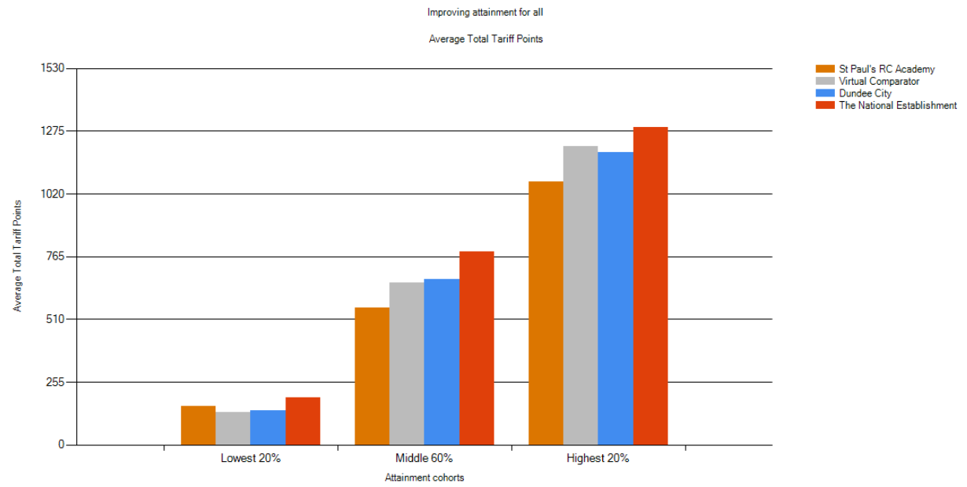

Establishment | Year | Lowest 20% | Middle 60% | Highest 20% | Number in Cohort
St Paul's RC Academy | 2025 | 155 | 557 | 1070 | 141
Virtual Comparator | 2025 | 131 | 659 | 1213 | 1410
Dundee City | 2025 | 140 | 673 | 1189 | 1231
St Paul's RC Academy | 2024 | 311 | 674 | 1068 | 131
Virtual Comparator | 2024 | 165 | 656 | 1210 | 1310
Dundee City | 2024 | 179 | 680 | 1172 | 1185
St Paul's RC Academy | 2023 | 294 | 767 | 1146 | 108
Virtual Comparator | 2023 | 181 | 673 | 1191 | 1080
Dundee City | 2023 | 171 | 676 | 1181 | 1125
St Paul's RC Academy | 2022 | 276 | 696 | 1096 | 133
Virtual Comparator | 2022 | 168 | 636 | 1189 | 1330
Dundee City | 2022 | 187 | 672 | 1164 | 1123

What does this mean?
This means that our Lowest attaining young people in S5 have attained more than our Virtual Comparator School and the Dundee City average. However, our Lowest attaining pupils have achieved greater results consistently since 2022 , similarly with our Middle attaining pupils. Our Highest attaining pupils are consistently beneath our Virtual Comparator.
What will we do now to improve?
Our school will track and monitor the progress of young people through S4 paying particularly attention to those at risk of leaving without achieving along with ensuring appropriate coursing is both ambitious and meaningful. Our Attendance Procedures will continue to impact on the improvements we are seeing by engaging with families at an early stage (Article 18 UNCRC) . Departments are also look at how we can maximise attainment by presenting pupils for additional qualifications where appropriate.
Local Benchmarking Measure: Improving Attainment for All (S6)

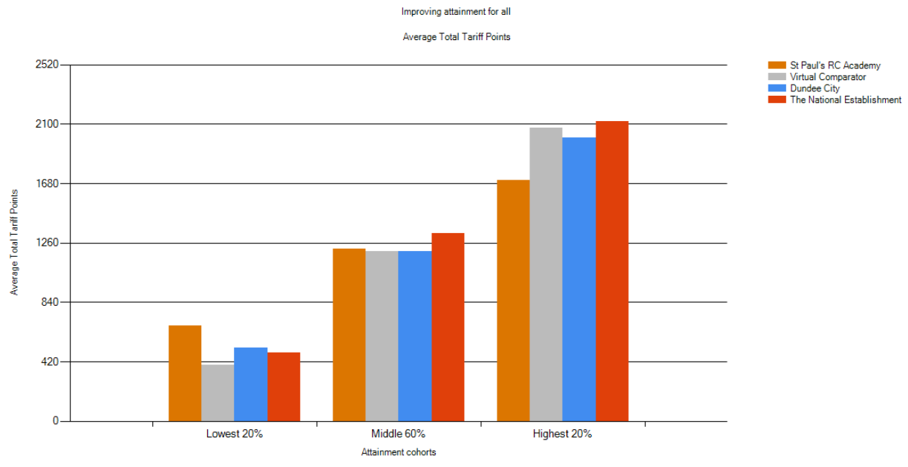
Establishment | Year | Lowest 20% | Middle 60% | Highest 20% | Number in Cohort
St Paul's RC Academy | 2025 | 672 | 1216 | 1702 | 83
Virtual Comparator | 2025 | 396 | 1197 | 2072 | 830
Dundee City | 2025 | 483 | 1201 | 2005 | 783
St Paul's RC Academy | 2024 | 790 | 1267 | 1908 | 70
Virtual Comparator | 2024 | 423 | 1126 | 1950 | 700
Dundee City | 2024 | 468 | 1205 | 2000 | 713
St Paul's RC Academy | 2023 | 562 | 1257 | 1776 | 79
Virtual Comparator | 2023 | 412 | 1134 | 1989 | 790
Dundee City | 2023 | 471 | 1223 | 2004 | 728
St Paul's RC Academy | 2022 | 596 | 1390 | 2025 | 71
Virtual Comparator | 2022 | 391 | 1185 | 2034 | 710
Dundee City | 2022 | 504 | 1238 | 2031 | 738

What does this mean?
This means that our Lowest attaining young people in S6 have attained significantly more than our Virtual Comparator School and the Dundee City average (equivalent to an additional 2 x Highers or 3 x National 5 qualifications) . This is also the case for our Middle attaining young people with the equivalent of an additional National 5 in comparison to our Virtual Comparator school. However, our Highest attaining young people are beneath our Virtual Comparator with the equivalent of 2 x Highers less).
What will we do now to improve?
Our school will track and monitor the progress of young people through S6 paying particularly attention to those at risk of leaving early without completing the course. The S6 Rationale for Retuning needs to ensure young people are progressing to a higher level and aiming for a focused reason to achieve in their final year; get the best that they deserve whilst respecting the guidance from home and the voice of the young person. (Article 5 & 12 UNCRC)
Local Benchmarking Measure: Attainment versus Deprivation (S4)

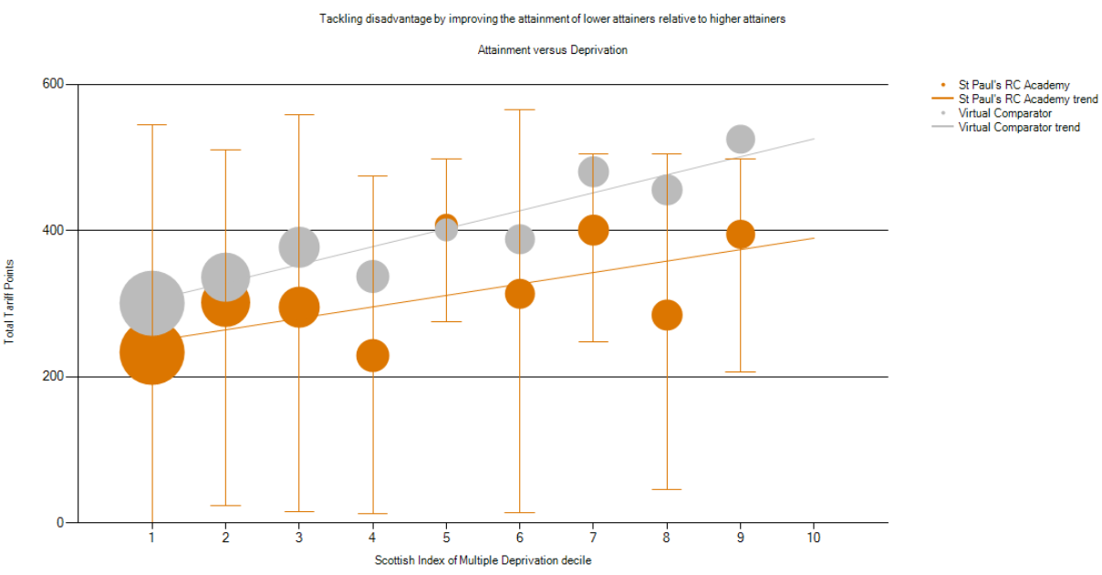
Establishment | Year | Number in Cohort | SIMD 1 % of Cohort | SIMD 1 Average | SIMD 2 % of Cohort | SIMD 2 Average | SIMD 3 % of Cohort | SIMD 3 Average | SIMD 4 % of Cohort | SIMD 4 Average
St Paul's RC Academy | 2024/25 | 194 | 40.72% | 233 | 20.10% | 302 | 12.37% | 295 | 6.19% | 229
Virtual Comparator | 2024/25 | 1940 | 40.72% | 301 | 20.10% | 336 | 12.37% | 377 | 6.19% | 337
St Paul's RC Academy | 2023/24 | 192 | 31.25% | 242 | 22.40% | 235 | 16.15% | 294 | 6.25% | 245
Virtual Comparator | 2023/24 | 1920 | 31.25% | 284 | 22.40% | 271 | 16.15% | 334 | 6.25% | 283
St Paul's RC Academy | 2022/23 | 195 | 35.90% | 265 | 18.46% | 312 | 11.28% | 335 | 5.64% | 263
Virtual Comparator | 2022/23 | 1950 | 35.90% | 293 | 18.46% | 315 | 11.28% | 319 | 5.64% | 316

SIMD 5 % of Cohort | SIMD 5 Average | SIMD 6 % of Cohort | SIMD 6 Average | SIMD 7 % of Cohort | SIMD 7 Average | SIMD 8 % of Cohort | SIMD 8 Average | SIMD 9 % of Cohort | SIMD 9 Average | SIMD 10 % of Cohort | SIMD 10 Average
1.55% | 407 | 4.64% | 313 | 5.15% | 400 | 5.15% | 284 | 4.12% | 395 | 0.00% | 0
1.55% | 401 | 4.64% | 388 | 5.15% | 480 | 5.15% | 456 | 4.12% | 525 | 0.00% | 0
0.52% | 504 | 3.65% | 229 | 7.81% | 364 | 9.38% | 343 | 2.08% | 309 | 0.52% | 169
0.52% | 418 | 3.65% | 371 | 7.81% | 419 | 9.38% | 464 | 2.08% | 321 | 0.52% | 552
2.56% | 364 | 2.05% | 357 | 14.36% | 353 | 6.67% | 321 | 2.56% | 349 | 0.51% | 34
2.56% | 408 | 2.05% | 452 | 14.36% | 417 | 6.67% | 474 | 2.56% | 490 | 0.51% | 626
What does this mean?

SIMD refers to the Scottish Multiple of Deprivation. This outlines our most (SIMD1) and least (SIMD 10) deprived areas that our young people live in. Our most deprived families in SIMD 1& 2 account for over 60% of the S4 year group 2024/25. As a group, they are not achieving as high as our Virtual Comparator.

What will we do now to improve?
We will continue to focus on Attendance with data showing that our S4 cohort has the lowest attendance in year groups across the school. Through use of our Pupil Equity Funding, we will address barriers that prevent our most deprived young people from achieving their potential through monitoring, tracking, family engagement and support from our partner agencies. (Article 28 UNCRC).
Local Benchmarking Measure: Attainment versus Deprivation (S5)

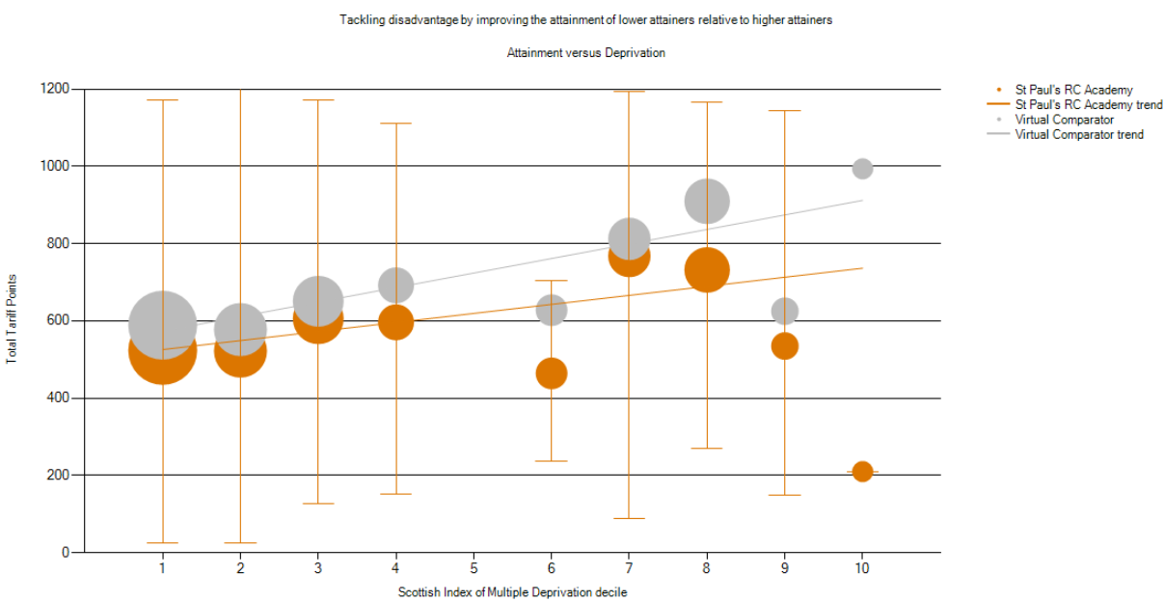

Establishment | Year | Number in Cohort | SIMD 1 % of Cohort | SIMD 1 Average | SIMD 2 % of Cohort | SIMD 2 Average | SIMD 3 % of Cohort | SIMD 3 Average | SIMD 4 % of Cohort | SIMD 4 Average
St Paul's RC Academy | 2024/25 | 141 | 34.04% | 524 | 17.73% | 522 | 15.60% | 606 | 5.67% | 596
Virtual Comparator | 2024/25 | 1410 | 34.04% | 589 | 17.73% | 578 | 15.60% | 651 | 5.67% | 692
St Paul's RC Academy | 2023/24 | 131 | 28.24% | 619 | 19.08% | 703 | 12.21% | 738 | 4.58% | 584
Virtual Comparator | 2023/24 | 1310 | 28.24% | 556 | 19.08% | 623 | 12.21% | 600 | 4.58% | 670
St Paul's RC Academy | 2022/23 | 108 | 29.63% | 647 | 25.00% | 762 | 8.33% | 816 | 6.48% | 919
Virtual Comparator | 2022/23 | 1080 | 29.63% | 554 | 25.00% | 601 | 8.33% | 741 | 6.48% | 768

SIMD 5 % of Cohort | SIMD 5 Average | SIMD 6 % of Cohort | SIMD 6 Average | SIMD 7 % of Cohort | SIMD 7 Average | SIMD 8 % of Cohort | SIMD 8 Average | SIMD 9 % of Cohort | SIMD 9 Average | SIMD 10 % of Cohort | SIMD 10 Average
0.00% | 0 | 3.55% | 464 | 9.22% | 768 | 11.35% | 732 | 2.13% | 535 | 0.71% | 210
0.00% | 0 | 3.55% | 628 | 9.22% | 812 | 11.35% | 910 | 2.13% | 625 | 0.71% | 993
2.29% | 725 | 4.58% | 703 | 16.79% | 694 | 9.16% | 747 | 3.05% | 790 | 0.00% | 0
2.29% | 824 | 4.58% | 879 | 16.79% | 827 | 9.16% | 885 | 3.05% | 756 | 0.00% | 0
0.93% | 592 | 4.63% | 996 | 6.48% | 630 | 10.19% | 736 | 8.33% | 906 | 0.00% | 0
0.93% | 649 | 4.63% | 709 | 6.48% | 815 | 10.19% | 849 | 8.33% | 953 | 0.00% | 0

What does this mean?

This means that we are closer to meeting the attainment levels of the most deprived young people in S5. Although there are smaller numbers in our least deprived categories, we need to challenge them more to achieve their potential. Our most deprived young people have the equivalent of 1 less National 5 qualification and our least deprived young people have the equivalent of 1 less Higher than our Virtual Comparator

What will we do now to improve?
We will focus on appropriate coursing by looking at Tariff Points already gathered in S4 along; progressional of levels along with the addition of a Level 6 SCQF First Aid qualification (Article 24 UNCRC).
Local Benchmarking Measure: Attainment versus Deprivation (S6)

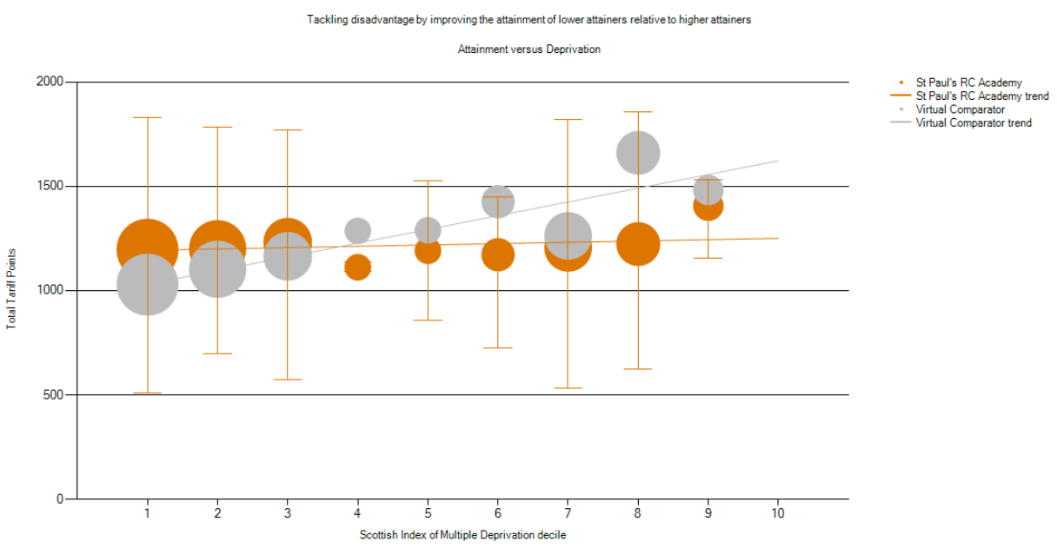

Establishment | Year | Number in Cohort | SIMD 1 % of Cohort | SIMD 1 Average | SIMD 2 % of Cohort | SIMD 2 Average | SIMD 3 % of Cohort | SIMD 3 Average | SIMD 4 % of Cohort | SIMD 4 Average
St Paul's RC Academy | 2024/25 | 83 | 26.51% | 1196 | 21.69% | 1201 | 14.46% | 1232 | 2.41% | 1112
Virtual Comparator | 2024/25 | 830 | 26.51% | 1029 | 21.69% | 1102 | 14.46% | 1164 | 2.41% | 1286
St Paul's RC Academy | 2023/24 | 70 | 22.86% | 1258 | 30.00% | 1256 | 7.14% | 1123 | 7.14% | 1130
Virtual Comparator | 2023/24 | 700 | 22.86% | 985 | 30.00% | 1036 | 7.14% | 1121 | 7.14% | 1132
St Paul's RC Academy | 2022/23 | 79 | 20.25% | 1199 | 12.66% | 1225 | 17.72% | 1045 | 8.86% | 1519
Virtual Comparator | 2022/23 | 790 | 20.25% | 995 | 12.66% | 1097 | 17.72% | 1035 | 8.86% | 1067
SIMD 5 % of Cohort | SIMD 5 Average | SIMD 6 % of Cohort | SIMD 6 Average | SIMD 7 % of Cohort | SIMD 7 Average | SIMD 8 % of Cohort | SIMD 8 Average | SIMD 9 % of Cohort | SIMD 9 Average | SIMD 10 % of Cohort
2.41% | 1191 | 4.82% | 1172 | 13.25% | 1205 | 10.84% | 1223 | 3.61% | 1407 | 0.00%
2.41% | 1289 | 4.82% | 1426 | 13.25% | 1262 | 10.84% | 1660 | 3.61% | 1482 | 0.00%
1.43% | 866 | 5.71% | 1804 | 7.14% | 1231 | 11.43% | 1311 | 7.14% | 1693 | 0.00%
1.43% | 1087 | 5.71% | 1207 | 7.14% | 1432 | 11.43% | 1445 | 7.14% | 1400 | 0.00%
1.27% | 1257 | 7.59% | 1144 | 13.92% | 1418 | 8.86% | 1321 | 7.59% | 1181 | 1.27%
1.27% | 1403 | 7.59% | 1151 | 13.92% | 1425 | 8.86% | 1305 | 7.59% | 1440 | 1.27%

What does this mean?
This means that our most deprived young people in S6 are achieving the equivalent of 1 Higher more than our Virtual Comparator. However, our least deprived young people (particularly in SIMD 8) are achieving less to the equivalence of 2 Highers.
What will we do now to improve?
We will aim to encourage our young people who receive unconditional offers to maintain the rigor of the year with regards to work ethic and preparation for positive destinations beyond school (Article 29 UNCRC).
The tables on the following pages show the percentage of pupils in each year group of the Senior Phase achieving awards at SCQF Level 4, Level 5, Level 6 or Level 7 for SQA exams, this equates to National 4, National 5, Higher and Advanced Higher.

This is followed by the school Attendance data and the school Exclusion data.
The tables on the following pages show the percentage of pupils in each year group of the Senior Phase achieving awards at SCQF Level 4, Level 5, Level 6 or Level 7 for SQA exams, this equates to National 4, National 5, Higher and Advanced Higher.

This is followed by the school Attendance data and the school Exclusion data.

What does this mean?

This means that the S4 number of awards at Level 3, 4, and 5(or better) have increased across all areas this year. We now have the highest % of young people achieving 6 or more A-D grade awards than ever before for SCQF Level 5, 4 and 3. Our young people are becoming achievers across more subjects.

What do we do now to improve?

We need to make use of the Leading Learners Study Skills programme to help give confidence and support to our young people to fully prepare for studying for assessments and examinations. This will help to maximise the quality of the passes they achieve (Article 29 UNCRC).

What does this mean?

This means that the S5 number of awards at Level 5, 6 (or better) have largely been maintained across the S5 cohort. However, there is a slight decline in the number of young people achieving 1 or 2 awards (at level 6 or 5) or better in their exam results.

What do we do now to improve?

We need to maximise the delivery of Level 6 across the school and ensure that returning S5 young people are progression upwards to another level and not sideways across numerous pathways. We need to support our young people with a clear direction and rationale for their choices by ensure that positive destinations are being discussed early on I the BGE. (S1-S3 ) – (Article 12 UNCRC).

What does this mean?

This means that the young people in S6 have improved on the number of awards they have achieved across Level 5, Level 6, Level 7 or better.

What do we do now to improve?

We need to maintain the slow but steady increase for the number of awards for our S6 pupils, particularly as this is their last opportunity to do so in school. We will make use of tracking accumulative Tariff Points for each child to look at the quality of passes and ensure early intervention to prevent a change of level (Article 29 UNCRC).

Attendance Rates
2024Establishment | 2019/20 | 2020/21 | 2021/22 | 2022/23 | 2023/24 | 2024/25
St Paul’s RC Academy | 87.8% | 87.4% | 83.9% | 83.6% | 84.8% | 86.4%
Dundee City | 88.0% | 90.4% | 85.9% | 88.5% | 89.0%

School Level Exclusion Rates (Incidents per 1000 pupils)
Establishment | 2019/20 | 2020/21 | 2021/22 | 2022/23 | 2023/24 | 2024/25
St Paul’s RC Academy | 18.9 | 19.2 | 27.7 | 45 | 54 | 68
Dundee City | 29.1 | 23.4 | 52.0 | 33.5 | 27.5

Review of Improvement Progress for Session 2024-2025
Cycle of Improvement

Based on Summary Self-evaluation, School Improvement Report,
Annual Audit, Extended Review, and feedback from Key Partners

Improvement Priorities for Session 2024-2025
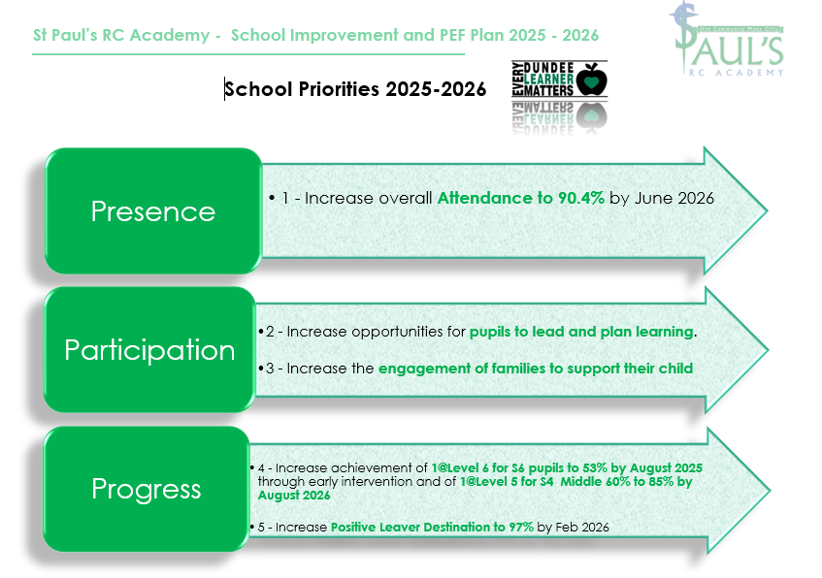

Please visit https://education.gov.scot/what-we-do/inspection-and-review/reports for or HMIE Inspection Reports.

Further Information can be found at:

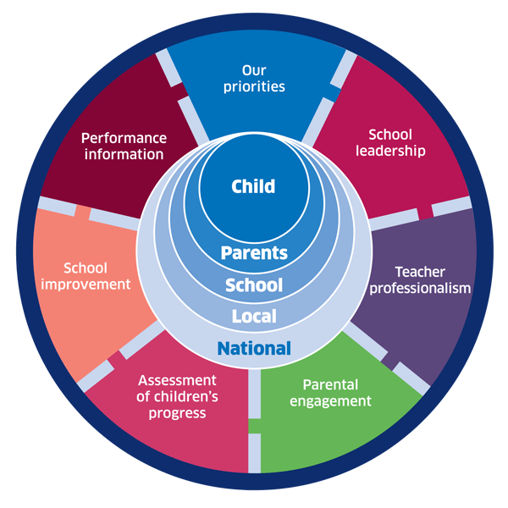 | 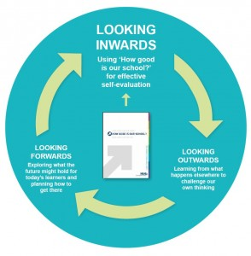 |  |   Dundee Education Plan  https://www.dundeecity.gov.uk/sites/default/files/publications/annual_education_plan_2017-18.pdf
National Improvement Framework  http://www.gov.scot/Publications/2016/01/8314 | HGIOS 4 Self-evaluation https://education.gov.scot/improvement/Documents/Frameworks_SelfEvaluation/FRWK2_NIHeditHGIOS/FRWK2_HGIOS4.pdf | Tayside Plan C&FS  Tayside_Plan 1a.pdf'

