School Context as at 17th November 2025

School Roll | School Attendance | Percentage ASN | PEF Allocation
1049 | 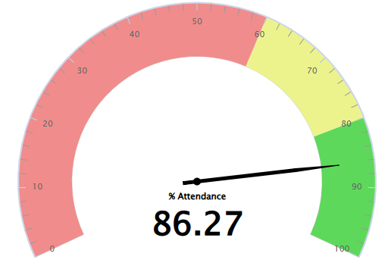 | 52.29%  (25% have 2 or more ASN ) | £232 750
SIMD (Quintiles) Profile | Percentage CEYP | Percentage Young Carers | Exclusions
 | 4.69% (31) | 6.64%  (79) | 11  (10 pupils)  (1 is repeated)

Vision Values and Aims

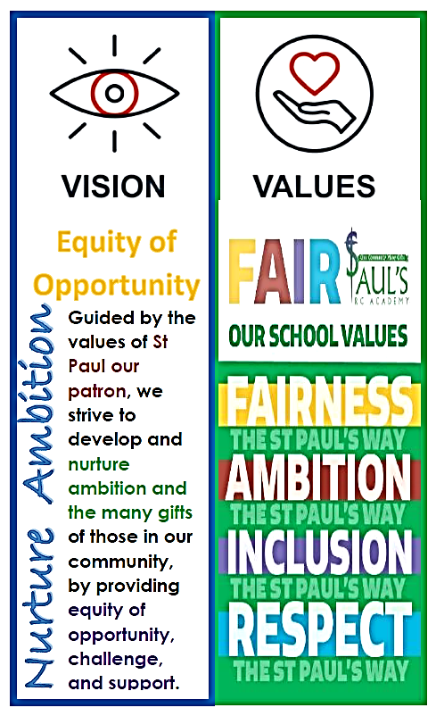
Our Aims:
1 Learning and Teaching
To create a learning culture of the highest aspirations and motivation where all young people are engaged and challenged to achieve their full potential. In every classroom, dynamic, varied teaching and learning allows pupils to become successful learners, confident Individuals, responsible citizens and effective contributors to society.

2 Ethos and Life of our School
To ensure that our Gospel Values are embedded throughout our community and that we work and learn together in a safe, secure and happy environment, setting high expectations for all, where our young people will thrive.

3 Personal Support
To nurture individuality and uniqueness in all members of the St Pauls community. To provide the highest level of support we will work closely with other professionals and continue to extend our partnerships to ensure all our Young People are given equal opportunities to maximise their potential.

4 Assessment, Attainment and Achievement
The staff at St Pauls will ensure that pupils are supported in their learning journey by giving them a clear picture of what they should learn, share criteria for success in every lesson and encourage engagement in opportunities for wider achievement.

5 Professionalism and Professional Development
We are committed to self-evaluation to identify ways that we can improve our professional skills and knowledge through Career Long Professional Learning to the benefit of our young people.

6 Working with Partners
To develop high quality partnerships to enable our curriculum to offer the widest possible range of academic and vocational courses to ensure all our Young People are given equal opportunities to maximise their potential and the appropriate support to enhance learning and teaching.

Cycle of Improvement


School Priorities 2025-2026

SCHOOL VERSION SIP Priority 1
Specific area for improvement |  |  | Increase Attendance to 90.4 % by June 2026
Rationale for Improvement  (based on evidence from key stakeholders) |  |  | Overall attendance continues to be below DCC Stretch Aim for 2025/26 90.4%
Equity Gap (if relevant) |  |  | End of June 2025 overall attendance was 86.4% . Highest % of absence was SIMD 1 at 16.44% followed by SIMD 3 at 14..92% then SIMD 10 at 13.56%  Quintiles absence (1 – 32.6%, 2 – 34.08%, 3 – 23.59%, 4 – 21.84%, 27.82%)rj1266
NIF PRIORITIES  Closing the attainment gap between the most and least disadvantaged children and young people  Improvement in children and young people's health and wellbeing  Choose an item.  Choose an item.  Choose an item. | NIF DRIVERS  School Improvement  Performance Information  Choose an item.  Choose an item.  Choose an item.  Choose an item. |  |  | EDLM PRIORITY    Presence |  | PEF (where applicable)  Intervention for equity & cost  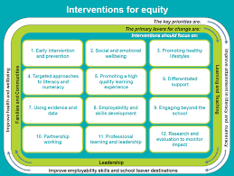  1. Early Intervention and Prevention  10. Partnership working  4. Targeted approaches to literacy and numeracy |  | HGIOS QI  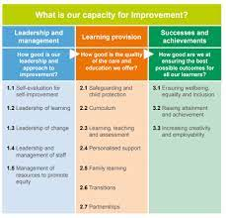  3.2 Raising attainment and achievement  2.3 Learning, Teaching and Assessment
Intended Outcome (impact) |  | Actions required to reach desired outcome |  |  | Measurement & Evidence |  | Who |  | When | Resources
For the overall School Attendance percentage to be at 90.4% in June 2026 by children feeling safe, included and supported when they are here. Cluster Plan to focus on Ethos and Relationships via the Forth Valley tool . |  | - PT Inclusion to focus upon for Flexible Learning Plans and re-integration and to help raise attainment of disengaged learners through monitoring and tracking of impact on behaviour/attendance.  - Review and modify the Relationship for Learning Policy (see Included , Engaged and Involved Part 2) in line with Scottish Government Guidance Schools - fostering a positive, inclusive and safe environment: guidance - gov.scot  - All Attendance Monitoring to use Contextualised Data Groups (i.e. SIMD, FSM, YC, ASN, CEYP) to assist the work of the Data Analysis Enquiry Group to help with targeting interventions.  - Ancrum Outdoor Provision 1 day a week to promote and support attendance.  - Develop programme of MENDing Mindsets and Mentors in Violence to help support Anti-Bullying and Positive Masculinity. |  |  | FLP Plans and Exclusion Figures  & Seemis Business Intelligence  Attendance-Self-Evaluation-Toolkit-Feb 2024  Violent Incident Reports  S:\StPaulsAdminData\ATTENDANCE\2024-2025 80percent record.xlsx  Ancrum Pre and Post Evaluations to determine impact on Attendance  "S:\StPauls Staff Share\Whole School\QUALITY ASSURANCE\Stakeholder Surveys\Survey Progress Sheet.xlsx" |  | - JD/ PD/ TR/ CMcC  2. KS & JN (DEPs)  3. T R  4. JD  5. JD |  | From August 2025 | PT Inclusion (PEF Funded)  0.4 FTE Outreach from PEF
Progress
Term 1 DCC Stretch Aim for 2025/26 – 90.4%
Baseline - June Attendance 2025 86.43 %
Baseline – “I feel safe when I am at school” May 2025 – 73% ( increase of 7pp from May 2024) - MAJORITY
Baseline – “ My school helps me to understand and respect other people” May 2-25 – 72% ( increase of 7pp from May 2024) – MAJORITY
Baseline – “Children and young people are well-behaved” May 2025 (33% decrease of 1pp from May 2024) LESS THAN HALF
Baseline – “My school deals well with any bullying” – May 2025 41% ( increase of 4pp from May 2024) LESS THAN HALF

Term2

Term 3

Term 4

SCHOOL VERSION SIP Priority 2
Specific area for improvement |  |  | Increase Opportunities for pupils to lead and plan learning and improvement
Rationale for Improvement  (based on evidence from key stakeholders) |  |  | Response from pupil and staff surveys focusing on not feeling involved in curriculum planning leading to disengagement in learning.
Equity Gap (if relevant) |  |  | n/a
NIF PRIORITIES  Placing the human rights and needs of every child and young person at the centre of education  Improvement in children and young people's health and wellbeing  Choose an item.  Choose an item.  Choose an item. | NIF DRIVERS  Assessment of Children's Progress  Teacher Professionalism  Choose an item.  Choose an item.  Choose an item.  Choose an item. |  |  | EDLM PRIORITY  Participation |  | PEF (where applicable)  Intervention for equity & cost  5. Promoting a high quality learning experience  6. Differentiated support  Choose an item. |  | HGIOS QI  1.2 Leadership of learning  2.3 Learning, Teaching and Assessment
Intended Outcome (impact) |  | Actions required to reach desired outcome |  |  | Measurement & Evidence |  | Who |  | When | Resources
Pupils to feel ownership over their learning and for the response in future surveys to show an increase to “Most” (75-90%) along with CSV’s.  Classroom Support Visits/Learning & Achievement Meetings provide evidence of pupils leading learning across the school and increased level of engagement. |  | - Focus on Classroom Support Visits for BGE and Senior Phase to show Pupils leading learning.  - Planning for Learning and Teaching to be reviewed in Curriculum Reviews with a focus on Planning Tools.  - CLPL Calendar to be created to ensure in house Professional Learning and good practice is shared around learning and teaching  - Pupil Council to be re-established and re-invigorated to gain regular feedback from Pupil Voice on L&T and improvement across the school. |  |  | Classroom Support Visits/ Learning Conversation Meetings to provide evidence of pupils leading learning across the school. Leuven Scale for targeted pupils.  Curriculum Review Feedback and Summaries for whole school  CLPL Calendar and feedback from staff/evidence from learning walks/ DM minutes  Pupil Survey Response in May 2026/Feedback from Pupil Focus Groups on Inclusive Practice Classroom. |  | 1. AMcF  - TR  - AMcF  - KS |  | By June 2025 | ThingLink Forth Valley Tool for Self-Evaluation
Progress
Term 1
Baseline – “I am given the opportunity to influence what and how I learn” – May 2025 – 69% (increase of 9pp from May 2024) MAJORITY
Baseline – “The feedback I receive on my work helps me to improve my learning.” – May 2025 – 78% (increase of 10pp from May 2024) MOST
Baseline – “ Children and young people have the opportunity to lead their learning.” – May 2025 – 63% (increase of 8pp from May 2024) MAJORITY
Baseline – “ Children and young people are involved in talking about and planning their learning.” – May 2025 – 64% ( increase of 8pp from May 2024) MAJORITY

SCHOOL VERSION SIP Priority 3
Specific area for improvement |  |  | Increase of the engagement of families
Rationale for Improvement  (based on evidence from key stakeholders) |  |  | Less than half of families reported that there are opportunities for them to learn with their child.
Equity Gap (if relevant) |  |  | Type here
NIF PRIORITIES  Closing the attainment gap between the most and least disadvantaged children and young people  Improvement in attainment, particularly in literacy and numeracy  Choose an item.  Choose an item.  Choose an item. | NIF DRIVERS  Parental Engagement  Assessment of Children's Progress  Choose an item.  Choose an item.  Choose an item.  Choose an item. |  |  | EDLM PRIORITY  Participation |  | PEF (where applicable)  Intervention for equity & cost  9. Engaging beyond the school  Choose an item.  Choose an item. |  | HGIOS QI  2.5 Family Learning  3.2 Raising attainment and achievement
Intended Outcome (impact) |  | Actions required to reach desired outcome |  |  | Measurement & Evidence |  | Who |  | When | Resources
Parents/Carers feeling empowered to support young people in their learning and to make positive choices to help their futures.  The school gives me advice on how to support my child's learning at home “Most” (75-90%)  The school organises activities to learn with their child increases to “Majority” (50-75%) |  | - Targeted Sessions to help support families with low levels of engagement via the Family Learning Framework  - Track and monitor TATC meetings via MS Forms Feedback to ensure voices are heard.  - Increase Participation of Parent Council Members with regards to School Improvement and decision Making  - Improve communication to a more accessible platform through Padlet with Departmental input. |  |  | Parent/Carer Survey May 2025  MS Form Responses on TATC Experience  Attendance and Parent Council Minutes  Response to Parent Carer Survey 2026 and engagement/activity with Padlet fed back via Parent’s Night. |  | - J D  - JD  - KS  - KS |  | Ongoing 2025-26 | Family Learning Framework
Progress
Term 1
Baseline “ The school gives me advice on how to support my child’ learning at home” – May 2025 – 53% ( decrease of 1pp from May 2024) MAJORITY
Baseline “ The school organises activities where my child and I can learn together” – May 2025 – 25% ( increase of 4pp from May 2024) LESS THAN HALF
Baseline “ The school takes my views into account when making changes.” – May 2025 – 52% ( no change from May 2024) MAJORITY

Term 2

SCHOOL VERSION SIP Priority 4
Specific area for improvement |  |  | Increase achievement of 1@Level 6 (A-C) for S6 pupils to DCC Stretch Aim for 56% by end of Session 2025/26 and 1@ Level 5 for Middle 60% pupils
Rationale for Improvement  (based on evidence from key stakeholders) |  |  | August 2024 figures stand at 48% 1@ Level 6 (A-D) for S6 pupils.
Equity Gap (if relevant) |  |  | (TBC for August figures)
NIF PRIORITIES  Placing the human rights and needs of every child and young person at the centre of education  Improvement in attainment, particularly in literacy and numeracy  Improvement in skills and sustained, positive school-leaver destinations for all young people  Choose an item.  Choose an item. | NIF DRIVERS  Performance Information  Teacher Professionalism  Assessment of Children's Progress  Choose an item.  Choose an item.  Choose an item. |  |  | EDLM PRIORITY  Progress |  | PEF (where applicable)  Intervention for equity & cost  5. Promoting a high quality learning experience  7. Using evidence and data  1. Early Intervention and Prevention |  | HGIOS QI  2.3 Learning, Teaching and Assessment  3.2 Raising attainment and achievement
Intended Outcome (impact) |  | Actions required to reach desired outcome |  |  | Measurement & Evidence |  | Who |  | When | Resources
Increase achievement of 1@Level 6 (A-C) for S6 pupils to 53% by August 2025 with DCC Stretch Aim for 56% by end of Session 2025/26.  Level 4 ACEL levels to increase in line with listening and talking to 45%. By end of Session 2025/26 |  | - Robust and consistent Tracking and monitoring of New S4-S6 to ensure Challenge and Early Intervention with identification of Attainment for All categories.  - Building on the Leading Learners Programme to expand across the departments for learning and understanding.  - Early intervention on raising Literacy and Numeracy Levels reported with PandA data from S1.  - Supporting Learner Teacher of Numeracy/Literacy to focus on targeting individual in BGE to help raise attainment. |  |  | DCC Stretch Aim for 56% by end of Session 2025/26.Stretch aims 2023 school level 2024 update.docx  STOP check (Senior Tracking Of Progress) 1@ Level 6 SQA Results S5 cohort August 2024.xlsx  Tracking of Leading Learner’s Participant on Whole School Tracking for Senior Phase. STOP Senior Tracking Of Progress 2025-26.xlsx  Use of new Pupil Tracking system for Lit and Num but introducing BGE in 2025-26 and PandA  Tracking of key individual via above Tracking tool. |  | - TR  - KS/ AMcF  - AMcF/TR  - TR/ MB |  |  | Insight Data Updates  Leading Learners PEF Funding
Progress
Term 1 - DCC Stretch Aim for S6 pupils of pupils gaining 1 or more awards at SCQF Level 6 or better for 56% by end of Session 2025/26.
Baseline – August 2024 - 51%. 1@ SCQF Level 6 (TBC for August 2025)

Baseline – S3 ACEL Data - (Highest Level of Level 2 at 23% compared to rest of DCC ).
ACEL June 2025 | S3 Level 4 % Cohort of 200
Reading | 35
Listening & Talking | 35
Writing | 36
Literacy | 34
Numeracy | 37

New S1 Intake – P7 PandA Mar 2025 – 0.2 T – (cohort of 194)
PandA Mar 2025 | 0.2T | 0.1A | 0.1T | 0.1L | 0.1U | 0.0U | E | E.U | Mile | No data
Listening & Talk | 3 (2%) | 1 (0.5%) | 153 (79%) | 12 (6%) | 10 (5%) | 1 (0.5%) | 2 (1%) | 7 (4%) | 4 (2%) | 1 (0.5%)
Writing | 4 (2%) | 6 (3 %) | 103 (56%) | 39 (20%) | 18 (9%) | 1(0.5%) | 2 (1%) | 14 (7.2%) | 4 (2%) | 1 (0.5%)
Reading | 3 (2%) | 8 (4%) | 120 (62%) | 27 (14%) | 16 (8%) | 0 | 2 (1%) | 10 (5%) | 4 (2%) | 1 (0.5%)
Numeracy | 5 (3%) | 7 (4%) | 101 (52%) | 27 (14%) | 33 (17%) | 0 | 2 (1%) | 11 (6%) | 4 (2%) | 1 (0.5%)

SCHOOL VERSION SIP Priority 5
Specific area for improvement |  |  | Increase Positive Leaver Destination to 97% by Feb 2026
Rationale for Improvement  (based on evidence from key stakeholders) |  |  | Feb 2025 Insight showed 95.76% found a positive destination. ( greater than VC by 2.62 PP and greater than DCC by 1 PP. Less than half of the pupils felt they were encouraged to do the best they can all of the time. – Already surpassed DCC Stretch Aim for 2025/26.
Equity Gap (if relevant) |  |  | Quintile 1 significantly higher than VC by 3.67 PP 2023/24 Leavers  Quintile 2 lower than VC , Quintile 3, 4 and 5 – 100% Leaver destination.
NIF PRIORITIES  Improvement in skills and sustained, positive school-leaver destinations for all young people  Placing the human rights and needs of every child and young person at the centre of education  Choose an item.  Choose an item.  Choose an item. | NIF DRIVERS  School Improvement  Assessment of Children's Progress  Performance Information  Choose an item.  Choose an item.  Choose an item. |  |  | EDLM PRIORITY  Participation |  | PEF (where applicable)  Intervention for equity & cost  9. Engaging beyond the school  10. Partnership working  11. Professional learning and leadership |  | HGIOS QI  1.3 Leadership of change  3.3 Increasing creativity and employabiity
Intended Outcome (impact) |  | Actions required to reach desired outcome |  |  | Measurement & Evidence |  | Who |  | When | Resources
That the maximum possible of pupils leave to go to an identified Positive Destination including those who access Outreach Support. The Stretch Aim would be for 97% by Feb 2026 data release. |  | - Use of the Inclusion Hub and Outreach Teacher to ensure that all children leave with the minimum of Literacy and Numeracy National Level including SSW .  - Dept meetings with DYW worker to ensure that opportunities as shared for a variety of pathways and to experience different industries/ sectors to see how this can be promoted or linked to their subject.  - Targeted work with early identification of STARS via the CIG. Outward Bound also supporting development of Employability Skills. |  |  | Insight figures of Positive Destinations – 95.76%  SDS Management Information Reports on School Service Office  Feedback from DM’s and DYW Monthly Log  Positive Destination Framework CIG Tracking and Monitoring of STARS.  Outward Bound Evaluations and Data Tracking |  | - A McF/ TR/ JD  - AMcF/ RB (DYW)  - AMcF / F McC (PTG) |  | February 2026 Insight Data | Outreach Support Teacher 0.4 FTE  Annual Participation Measure - Skills Development Scotland
Progress
Term 1
DCC Stretch Aim for 2025/26 – 95%
Baseline – Feb Insight Feb 2025 Baseline figure of Positive Destinations – 95.76%

Feb Insight Data read at higher than VC, DCC and National.
Positive Destination Framework work beginning with a focus on targeted STARS

Summary of PEF Spend
Area of expenditure | Details | Reference to Plan | Budgeted allocated
Teaching staff | 0.4 FTE Outreach Teacher  1.0 FTE PT Inclusion  DofE Additional Days for Expeditions/Practice Walks | As per SIP above  Plan/Additional PEF  As per SIP above | £110,000
Support staff | 0.6 FTE Pupil Support Worker  1.8 Learning and Care Assistant  Young Carers School Support Worker Fees | See CoSD Plan  As per SIP above  Additional PEF | £42,000
Supported study |  |  | TBC
Transport | Transport funding for trips or those unable to fund the full cost of a trip including Residential. | See CoSD Plan | £10,000
CLPL |  |  | £4000
Resources | Educational Materials  Subscriptions  Departmental Resources  Misc Supplies and Services  School Uniform/PE Kit  Breakfast Club | As per SIP above  See CoSD Plan  See CoSD Plan/Additional PEF | £43369  £5489  £37, 871  £35,500  £4000  £1000
Payments to other bodies | Place 2 BE  Includem  Dundee West  Outward Bound  Ancrum Outdoor Centre |  | £41,709
Other (please specify) | Apprenticeship Levy |  | £158
OVERALL TOTAL |  |  | £286,736

SCHOOL VERSION
Further PEF Interventions  (not included in SIP ) |  |  | Type here
Equity Gap (if relevant) |  |  | Type here
NIF PRIORITIES  Choose an item.  Choose an item.  Choose an item.  Choose an item.  Choose an item. | NIF DRIVERS  Choose an item.  Choose an item.  Choose an item.  Choose an item.  Choose an item.  Choose an item. |  |  | EDLM PRIORITY  Choose an item. |  | PEF (where applicable)  Intervention for equity & cost  Choose an item.  Choose an item.  Choose an item. |  | HGIOS QI  Choose an item.  Choose an item.
Intended Outcome (impact) |  | Actions required to reach desired outcome |  |  | Measurement & Evidence |  | Who |  | When | Resources
This should include your intended impact (stretch aim) |  | Identify the specific actions that will ensure impact on the above priority. |  |  | Including baseline measurement methodology. Including use of HGIOS Challenge questions where appropriate
Progress
This box should be used to note progress throughout the session

