
ST PAUL’S RC ACADEMY
HANDBOOK 2025

Contents

Section 1 Welcome

Section 2 School Ethos

Section 3 School Information

Section 4 School Policies and Practical Information

Section 5 Parental Involvement

Section 6 Curriculum

Section 7 Support for Pupils

Section 8 School Improvement

Section 9 Extra Curricular Activities

As Headteacher of St. Paul’s RC Academy I take great pride in welcoming you to our school community. We are very motivated by the determination and ambition of our young people; alongside the care and support given by our staff, we join our students in their journeys towards academic successes and many achievements. Our investment in our school motto of “One Community Many Gifts”, is evident in how we recognise the individuality of God’s children and the strength in a community to raise and nurture a child.

The aim of Catholic Education is to educate the whole child, develop their talents and allow them to live out our School Values in the fullest possible way, thereby transforming their lives for the better. The Gospel Values are embedded throughout our practice and the best testimonials for our school can be found in the interactions of our pupils, our staff and our parents and carers.

We encourage and support every pupil to achieve their personal best in all that they and promote a sense of limitless ambition. We expect the highest standards from our young people in all aspects of school life, in their attitude to learning, their personal conduct and in their appearance.

We aim to create a learning culture where our pupils feel safe, happy and valued, as they develop into young people who are confident in their own ability and contribute effectively to the school and the wider community.

This Handbook provides information about our school for parents and carers whose children will be making the transfer from primary school, or from other secondary schools. Our Primary Transition work starts in September and continues to the Induction Days in June. This process allows pupils from our associated primary schools to get to know our staff and the layout of the building all whilst meeting other young people from across our catchment area.

For those who are transferring at other stages there will be individual or targeted arrangements. This usually involves a pre-enrolment meeting with the appropriate member of the Senior Leadership Team, a tour of the school and an introduction to some staff and future classmates.

However, a handbook cannot replace personal contact; that is still the most important form of communication, so if you would like more information or wish to visit the school, then please do not hesitate to contact the School Office and appropriate arrangements can be made. We are very proud of our school community, and when you take the opportunity to come and meet us, we are confident you will see why.

Finally, I hope this handbook provides information that you will find helpful as your child moves into the school and I look forward to meeting you as new members of our school community.


Mrs Kirsty Small
Head Teacher
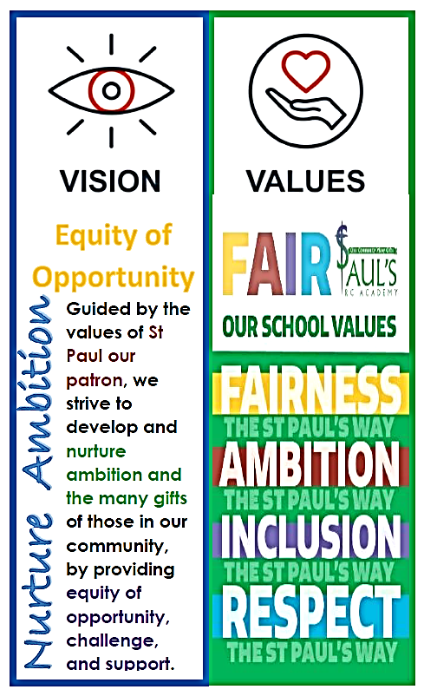
Our School Vision
Guided by the values of St Paul our patron, we strive to develop and
nurture ambition and the many gifts of those in our community, by
providing equity of opportunity, challenge, and support.

Our School Values
FAIRNESS AMBITION INCLUSION RESPECT

Our Aims:
1 Learning and Teaching
To create a learning culture of the highest aspirations and motivation where all young people are engaged and challenged to achieve their full potential. In every classroom, dynamic, varied teaching and learning allows pupils to become successful learners, confident Individuals, responsible citizens and effective contributors to society.
2 Ethos and Life of our School
To ensure that our Gospel Values are embedded throughout our community and that we work and learn together in a safe, secure and happy environment, setting high expectations for all where our young people will thrive.
3 Personal Support
To nurture individuality and uniqueness in all members of the St Pauls community. To provide the highest level of support we will work closely with other professionals and continue to extend our partnerships to ensure all our Young People are given equal opportunities to maximise their potential.
4 Assessment, Attainment and Achievement
The staff at St Pauls will ensure that pupils are supported in their learning journey by giving them a clear picture of what they should learn, share criteria for success in every lesson and encourage engagement in opportunities for wider achievement.
5 Professionalism and Professional Development
We are committed to self-evaluation to identify ways that we can improve our professional skills and knowledge through Career Long Professional Learning to the benefit of our young people.
6 Working with Partners
To develop high quality partnerships to enable our curriculum to offer the widest possible range of academic and vocational courses to ensure all our Young People are given equal opportunities to maximise their potential and the appropriate support to enhance learning and teaching.

General information

School Address: St Paul’s RC Academy
90 Gillburn Road
DUNDEE
DD3 0EH

Telephone: 01382 307701

Email: stpaulsrcacademy@dundeeschools.scot

Website: http://st-pauls.ea.dundeecity.sch.uk/

Senior Leadership Team
Head Teacher Mrs Kirsty Small

Depute Head Teacher Ms Jillian Divers
Ms Anna McFarlane
Mr Tommy Reilly

Business Manager Ms Fiona Gilroy

School Status Denominational S1-S6

School Roll 1042

School Hours Monday-Wednesday 8:45 to 15:40
Thursday/Friday 8:45 to 14:50

Parent Council Contact Info
Chair Ms Claire Cummings
Email stpauls@dundeeparentcouncil.org

School Chaplain: Father Michael Ngobili

Office Hours
The school office is open from 8:00 to 16:00. Please help us by making routine telephone calls within office hours. The answering machine is switched on for your convenience when the school office is unmanned. Please do leave a message and we will return your call as quickly as possible.
Each pupil will be allocated to one of the six houses where their Registration Teacher, Guidance Teacher and House Head will work to form a very close team which will allow these staff to support the young people on a day-to-day basis. Guidance teachers or House Heads will usually be the main point of contact for parents or pupils if they have any concerns.

House Groups
The House Groups are as follows:
St Andrew’s
House Head: Ms Jillian Divers
Guidance Team: Mr Finbarr McCarthy
SfL Link : Mr Andrew Blacklaw

St Columba’s
House Head: Ms Jillian Divers
Guidance Team: Mrs Sandra Ansquer
SfL Link: Ms Ashliegh Gray

St Katherine’s
House Head: Ms Anna McFarlane
Guidance Team: Ms Karen Girolami
SfL Link: Vacant

St Margaret’s
House Head: Mr Tommy Reilly
Guidance Team: Miss Bernie Flynn
SfL Link: Vacant

St Ninian’s
House Head: Mr Tommy Reilly
Guidance Team: Mrs Lynn Andrews
SfL Link Mrs Holly Clark

St Patrick’s
House Head: Ms Anna McFarlane
Guidance Team: Miss Leigh Selvey
SfL Link : Mrs Susan Bovill

School term dates

Autumn Term
- Monday 18 August 2025 - Staff resume
- Tuesday 19 August 2025 - Pupils resume
- Friday 3 October 2025 - Term ends
Autumn Holiday
- Monday 6 October 2025 - Holiday starts
- Friday 17 October 2025 - Holiday ends
Winter Term
- Monday 20 October 2025 - All resume
- Thursday 13 November 2025 - In service day, schools closed
- Friday 14 November 2025 - In services day, schools closed
- Tuesday 23 December 2025 - Term ends
Christmas Holiday
- Wednesday 24 December 2025 - Holiday starts
- Tuesday 6 January 2026 - Holiday ends
Spring Term
- Wednesday 7 January 2026 - All resume
- Friday 13 February 2026 - Mid term, schools closed
- Monday 16 February 2026 - Mid term, schools closed
- Tuesday 17 February 2026 - In service day, schools closed
- Thursday 2 April 2026 - Term ends
Spring Holiday
- Friday 3 April 2026 (Good Friday) - Holiday starts
- Friday 17 April 2026 - Holiday ends
Summer Term
- Monday 20 April 2026 - All resume
- Monday 4 May 2026 - May Day, schools closed
- Friday 22 May 2026 - In service day, schools closed
- Monday 25 May 2026 - Victoria Day, schools closed
- Friday 3 July 2026 - Term ends

Further information about school holiday dates can be found on the Dundee City Council website at:
School Term Dates | Dundee City Council

School Uniform

There is an expectation for all pupils to wear the correct school uniform. This helps us in our aim of encouraging children to take a pride in their appearance and to have respect for their school.

Our expectations:
Black trousers or black skirt
White shirt or blouse
Plain black sweatshirt, cardigan or hoodie
School tie
Black shoes

Optional:
Senior pupils (S4/5/6) are encouraged to wear the St Paul’s School Blazer

School ties can be purchased direct from the school via ParentPay. Pupils who fail to adhere to our expectations may be challenged. We strongly recommend that pupils only wear a black jacket/coat to school. Pupils may be asked to remove items such as jacket or coat which does not comply with this recommendation. Pupils should avoid wearing any clothing that includes a logo. We also discourage pupils from wearing high fashion items, jewellery or very short skirts/shorts.

PE Kit

Pupils are required to bring appropriate PE kit to all PE lessons.

Boys Girls
Plain Black or green t-shirt Plain Black or green t-shirt
Black shorts Black shorts or sports leggings
Indoor and outdoor trainers Indoor and outdoor trainers
Swimming trunks or shorts 1 piece swimming costume
Swimming cap Swimming cap
Goggles (optional) Goggles (optional)
Towel Towel

There is also an option to purchase embroidered and branded Nike or Joma items from Direct Soccer but there is no expectation that pupils must wear this.
If you need any financial assistance in supporting our drive for our young people to wear full school uniform daily, please contact the relevant guidance teacher in the first instance.

School clothing grants

If you are in receipt of Income Support, Job Seekers Allowance - Income Based, Income Related Employment and Support Allowance, Universal Credit (where take home pay is not more than £796 per month), Support under Part VI of the Immigration and Asylum Act 1999, Housing Benefit, Council Tax Reduction or Child Tax Credit with an income of less than £19,995 (as assessed by HMRC), you may be entitled to receive a grant towards the cost of buying essential clothing to enable children up to the age of 16 to attend school.
Grants are paid directly into your bank account. If you do not have a bank account we will contact you to discuss other payment options.

The current value of a Clothing Grant is £125 per primary school child and £155 per secondary school child.

Automatic awards

Most families will get an automatic award, which means they will not need to fill in a new application form each year.
You get an automatic award if you meet these conditions:
- you got an award in 2024/25 and
- you get Housing Benefit or Council Tax Reduction.
Payments will be made from 07 July onwards.
Otherwise, you must apply.
You will not get an automatic award if your child is entering P1.

Application forms can be made online at:
Free School Meals and Clothing (1.0) (dundeecity.gov.uk)

School Meals

Secondary schools operate self-service cafeterias. In secondary schools, the cost varies according to what the individual pupil chooses from the menu.

Special dietary requirements can be catered for, on the production of medical advice. Arrangements can be made for pupils who require special diets by contacting the Head Teacher.

All children staying for lunches within school will eat in the dining hall. Safety flasks containing hot food may be brought to school, but not the glass vacuum type, which may be dangerous, as they are liable to break. Glass bottles should not be brought to school.

Please inform us in writing if your child has any special dietary needs so that arrangements can be put in place to accommodate their needs.

The dining room is always supervised by school staff.

Free School Meals

Free school meals are available to all pupils whose parents receive Income Support, Job Seekers Allowance - Income Based, Income Related Employment and Support Allowance, Universal Credit where take home pay is not more than £850 per month, Support under Part VI of the Immigration and Asylum Act 1999.

Application forms can be made online at
Free School Meals and Clothing (1.0) (dundeecity.gov.uk)

Instrumental Tuition

Tuition fees and instrumental hire are free of charge

EMA

EMA is part of the Scottish Executive's agenda of encouraging access to, and participation in, further and higher education by young people from low-income families.

EMA provides financial support for 16 – 19 year olds who stay on in full time non advanced education or a community/voluntary Activity programme after their statutory school leaving date.

To be eligible for an EMA in 2024/25 the student must:
- Pupils born between 1st March 2006 and 30th September 2009 may be eligible for an award starting in August 2025.
- Pupils born between 1st October 2009 and 28th February 2010 may be eligible for an award starting in January 2026. Pupils eligible from January 2026 do not need to wait until January to submit their application form.
- Do you attend a Dundee school or do you reside in the Dundee area and are you undertaking a programme of learning in a community or voluntary setting?
- Is your household income:
  - £24,421 per annum or less (for families with a single dependent child) or
  - £26,884 per annum or less (families with more than one dependent child)?

EMA is a weekly allowance of £30 payable to eligible young people who have achieved 100% attendance per week. It is payable in arrears, generally on a 2-weekly basis.

To apply for EMA please contact:
EMA Team
Email: ema@dundeecity.gov.uk
Tel: 01382 433749

Payments to Schools

The school currently accepts payments online, using a secure website called ParentPay, for items such as school meals, trips and uniforms. The ParentPay system is easy to use and offers parents the freedom to make payments by debit or credit card, whenever they like, ensuring that monies reach schools safely and securely.
www.parentpay.com

Leaving Dates

Summer Leaving Date
A pupil whose sixteenth birthday falls on or after 1 March and before 1st October, is judged to have reached school leaving age on the 31st May.

Winter Leaving Date
A pupil whose sixteenth birthday falls on or after 1st October and before the last day of February, is judged to have reached school leaving age on the first day of the Christmas holidays.
Emergency School Closure Procedures

In exceptional circumstances the school may be unable to function normally. The school may be affected by severe weather or power failures. We shall do all we can to let you know about the details of closure and re-opening through the local radio, press, text messages and letters home. You can be assured that we will never send a child home without first checking that there is an adult at home.

Placing Requests

Parents of children living out with the school’s catchment area, who wish their child to attend the school, are asked to make a placing request. Forms can be obtained from the school. The child’s birth certificate and a proof of address, in the form of a Benefit Book, Council Tax book or recent (within 2 months) utilities account must be shown.

School Absence procedures

Please contact the school as soon as possible if your child is absent. The school encourages the use of Parents Portal app for notifying us of absences.

parentsportal.scot | The digital doorway to your child's school.

If your child is absent and no contact is made by you, a text message will be sent from the school. If three days pass without explanation for an absence an Education Welfare officer will arrange to visit you and your child at home.

The following points are included in the Education Authority’s Attendance Initiative
- If your child is ill and cannot attend school please contact the school before, or as soon as possible after 9am on the first day of absence.
- If the absence is planned, e.g. a hospital appointment, we ask you to let us know prior to the absence.
- If your child is absent for more than three days please call again or write to tell us.
- If you have not contacted the school to say your child is absent and have received a text message please contact us as soon as possible.

Regular attendance at school ensures your child is receiving the continuous education they are entitled to. Dundee City Council asks that, where possible, parents do not take children out of school for family holidays during term time. In accordance with Scottish Executive guidelines for pupil attendance, most holidays are recorded as unauthorised unless there is proof from an employer that this is the only time when holidays could be taken.

A guide for parents about school attendance explains parental responsibilities with regard to children’s attendance at school –
http://www.scotland.gov.uk/Publications/2009/12/04134640/0

Appointments

If your child has an appointment during the school day or needs to leave school for any other reason, please put this in writing. We would appreciate it if routine appointments could be made outwith school hours but understand that this isn’t always possible.

If your child does need to leave school during the school day they must be collected by a parent/carer at the main reception. In the interest of safety we cannot allow children to leave the school unaccompanied.

Accidents/illness at School

In the event of a child having an accident or becoming ill at school we will attempt to contact the parents or carers so that they can collect the child from school. However, if we cannot contact the parents, we will contact the Emergency Contact whose name and telephone number should be given to us by the parents.

Therefore, it is very important that parents inform the school of the name, address and telephone number of the Emergency Contact and advise the school immediately of any changes that occur.

Promoting Positive Behaviour

In St Paul’s RC Academy we strive to create an atmosphere which will enable teachers to deliver high quality Learning and Teaching and that our young people learn effectively and achieve at the highest level. All pupils are expected to contribute by supporting our standards for better learning, known as the St Paul’s Way.

St Paul’s Way

‘Our Standards for Better Learning’

Below are our school rules for pupils in St Paul’s
- We Listen
- We are ready
- We respect people
- We respect equipment
- We try our best
This means that in St Paul’s we expect that pupils will:
- Do what a teacher or other adult asks, the first time they ask
- Be prepared for class including bringing a PE kit
- Pay attention in class and work to the best of their ability
- Not encourage others to misbehave or keep them from working
- Not drop litter in or out of school and will put rubbish in a bin
- Only use a phone in class if asked by their teacher. Phones must be in school bags at all other times
- Attend all their classes and arrive on time
- Be polite to others at all times
- Not swear or use bad language, directly or indirectly
- Not bully others or use any form of physical violence
- Be well behaved when out of school including travelling to and from school
- Be a credit to our community in their behaviour, dress and attitude towards others

All teachers are expected to contribute by:
- Showing respect to all;
- Being well prepared and on time for every lesson;
- Working to encourage young people so that they achieve their full potential;
- Keep up to date with new developments and initiatives in Scottish Education

High expectations of pupils and staff should be evident in the ethos of the school and in the practice throughout St Paul’s forging the highest standard of behaviour and relationships.

An acceptable code of conduct is used to clarify expectations and foster a mix of firmness, fairness and common sense.

Disruption which causes interruption to the learning and teaching of others will lead to the application of a range of interventions.

Pupils who choose not to take a school lunch and bring their own food into school should try and make healthy choices. Hot meals purchased out of school may not be brought into or consumed in the school building. Food must be eaten in the snack bar, canteen or at the outside tables. All rubbish must be disposed of in the bins provided.

Pupils are allowed to bring into school;
- Drinks in a container up to 750ml
- Individual packets of crisps etc
- Sandwiches or other similar items

Pupils must not bring into school;
- Bottles of drinks bigger than 750ml
- Energy Drinks
- Family size packets of crisps, “Pringles” or other snack foods
- Hot food purchased out with school

Staff may challenge pupils not following the above guidelines and appropriate action will be taken, which may result in food/drinks being put in the bin. This is for the respect and safety of everyone in the school.

Pupils are not permitted to leave the school premises at break time.

School Concerns and Complaints Procedures

If you want to talk to your child’s teacher or a member of the Senior Leadership Team it is preferable to make an appointment. This ensures that the member of staff is available, that classes are not disturbed and that pupils’ lessons are not affected.

If you have made a complaint to the school and you are not satisfied with the outcome, you can have your complaint reviewed by a senior officer in the Children & Families Service Department.

Parental Involvement

In St Paul’s we are keen that parents and carers are fully involved and supported in helping their children learn. Parents/carers will receive regular information and updates regarding attendance, progress and behaviour in a variety of ways including text messages, e-mails, the School App, X /Twitter, school website as well as traditional reports, letters and newsletters.

As part of our involvement with parents St Paul’s is fortunate to have an active Parent Council. St Paul’s RC Academy Parent Council exists to support the school in its work with pupils and parents. It aims to represent the views of parents/carers and promote contact and communication between the school, home, pupils and the wider community. When those at home are involved in their child’s learning and in the life of the school, children do better.
St. Paul’s Parent Council has committed itself to working with staff and pupils to review the work of the school and particularly on promoting family learning.
The Parent Council meets at least once a term and is keen to involve new parents and guardians/carers and would therefore encourage you to come along to the meetings and support the school and all of our children’s education.
The current Office Bearers are:
Chairperson: Claire Cumming Secretary: Lisa Irwin
Treasurer: Fraser Christie

Should you wish to raise anything with the Parent Council, please contact the school or email
st-pauls@dundeeparentcouncil.org

Information regarding Dundee City’s Parental Involvement Strategy can be found on the Council Website. Parents/carers may also find the following websites useful in providing information as to how they can help their own children and become involved in their learning. Guidance on the Scottish Schools (Parental Involvement) Act 2006 provides guidance on the act for education authorities, Parent Councils and others –
http://www.scotland.gov.uk/Publications/2006/09/08094112/0

Learning and Achievement Interviews

Every pupil will have a 10 minute 1-1 interview with their Guidance Teacher at least once a year to which parents are invited. Further meetings are held with parents at choices time. Reports will be provided to parents before choices are made to ensure parents and pupils have full information.
Information evenings are held, choice booklets issued, PSE (Personal and Social Education) class time used to discuss and support pupil choice, and staff are always available to support pupils and parents/carers during the subject choice procedures.
In common with other schools we are required to record attainment in a systematic and user-friendly way, with the aims of:
- informing and supporting:
- pupils;
- parents/carers;
- teachers;
- promoted staff;
- other staff when pupils move school, stage or class; and
- the authority through its Quality Assurance process
- maximising attainment through the identification of individuals or groups where learning can be supported through the targeted use of resources
- ensuring appropriate but challenging pace of learning for all pupils
- ensuring best practice in learning and teaching which takes account of prior learning, learning styles and the quality of teaching
- promoting effective self-evaluation at individual, class and whole-school level

A systematic tracking system enables staff to form a clear picture of the current attainment and future expectations of individual children, groups of children and of the school. It requires teachers to agree next steps in learning with individual pupils and to set targets for future improvement. It acts as a very effective tool in communicating a child’s current level of attainment to parents throughout the year and when they move between schools.
Key Elements in tracking attainment
  - recognising achievement and commending the progress made to pupils and parents
  - tracking individual pupil, class and whole school progress in attainment
  - monitoring single child plans through the team around the child processes to ensure appropriate progress towards set targets
  - ensuring focused discussion with pupils and parents of baseline and other assessment data
  - analysing S1 SNSA data to facilitate pupil course choice and target-setting in S3
  - ensuring focused discussion with each class teacher regarding each individual pupil’s progress in classwork
  - ensuring full information about learning and how to support the child’s learning is shared with home regularly via phone calls, parents nights, learning and attainment meetings and other meetings as required

Tracking & Monitoring

Key members of the school staff will contribute to, and make use of, the tracking system in improving attainment:

Pupils
Pupils will be accustomed to sharing learning intentions and success criteria, working towards clearly established goals and receiving feedback appropriate to their level of attainment as part of their classroom experience. It is entirely appropriate, in the wider aspect of their developing a responsibility for their own learning, to involve them in setting targets, to encourage and support them in working to achieve these targets, and to expect them to seek feedback in relation to their progress.

Parents/Carers
We trust that the tracking system provides quality information for parents/carers on a regular basis. For instance, staff can highlight the achievement of high or improving levels of attainment but can also give early warning reports when performance is falling below expectations. The tracking system can also be used as an effective transition document when a child moves from one educational establishment to another. Parents/carers should expect that we are monitoring their child’s progress and will be able to provide them with an accurate and timeous response to any enquiries. We hope that parents will be involved in their child’s learning reports and that assessment is able to provide them with accurate evaluations of the child’s stage in learning, issues or problems which the child is encountering, and clear statements of the school’s expectations of the child.

School Staff and Roles
The Senior Leadership Team (SLT) will use the information generated from tracking pupil attainment to set and monitor whole school targets, take an overview in monitoring the progress of groups of pupils, and monitor the progress of subject departments.

Guidance Teacher roles and responsibilities
Guidance Teachers will use the information from pupil tracking to monitor the progress of groups of pupils, discuss targets across the curriculum with individual pupils, and, in the light of these discussions, ensure individual pupils have access to appropriate support and resources. In addition Guidance Teachers will set meaningful long-term targets, and analyse and discuss progress, with individual pupils and parents, and use the information gained to evaluate and review learning and teaching strategies.

Principal Teacher roles and responsibilities
PTs will manage target-setting for pupils within the subject department, monitor pupil progress, and use information from pupil tracking both to group pupils appropriately and evaluate learning and teaching strategies in the department. PTs will also contact home should any issues or particularly good progress require communication with parents.

Teacher roles and responsibilities
They are expected to carry out the initial target-setting exercise ensuring targets are realistic and ambitious, discuss targets and progress with parents/carers at Parent’s Evenings, review targets informally but regularly with pupils.

Curriculum for Excellence 3-18
Curriculum for Excellence was introduced to raise standards of learning and teaching for all pre-school to 18 year olds. It aims to help prepare children and young people with the knowledge and skills they need in a fast changing world. As part of Curriculum for Excellence all children from pre-school to the end of S3 will receive a rounded education know as a Broad General Education. Curriculum for Excellence is all about bringing real life into the classroom and taking lessons beyond it.

Through the experiences we provide we want our children to become Successful Learners, Confident Individuals, Responsible Citizens and Effective Contributors. We are committed to providing children with a broad general education and focus on eight curriculum areas.

Expressive Arts | Health & Wellbeing | Languages | Mathematics
Religious & Moral | Sciences | Social Subjects | Technologies

Progress in learning is indicated through curriculum levels as detailed below

Level | Stage
Early | The pre-school years and P1 or later
First | To the end of P4, but earlier or later for some
Second | To the end of P7, but earlier or later for some
Third & Fourth | S1-S3, but earlier for some

At the end of the Broad General Education (BGE), learners are supported in planning a course of study through what is referred to as the Senior Phase. The Senior Phase curriculum, from S4 to S6 (from around ages 15-18) follows on from a young person’s Broad General Education, building on the Experiences and Outcomes which they will have achieved to the end of S3. It enables them to extend and deepen their learning through more specialised study and to continue to develop skills for learning, life and work.

During the Senior Phase, young people will build up a portfolio of qualifications. It is the stage of education at which the relationship between the curriculum and National Qualifications becomes of key significance. The curriculum in the Senior Phase, however, comprises more than programmes which lead to qualifications. There is a continuing emphasis, for example, on health and wellbeing including physical activity and opportunities for personal achievement, service to others and practical experience of the world of work.

Learners have opportunities, at all stages, to gain recognition for learning and achievements which take place outside the classroom. The Senior Phase ultimately supports young people in moving on to the next stage – whether that is college, university, training or employment.

In the Senior Phase, schools and their partners (for example colleges, employers or community learning and development providers) now have flexibility to offer a range of pathways that meet the needs and raise the attainment levels of all learners.

As well as the new National Qualifications, which offer increased flexibility with a greater focus on skills and applying learning to real-life situations, there is also a wide range of SQA vocational qualifications and awards that young people can take as part of their senior phase curriculum.

These include skills for work,; leadership and personal development.
More specific and individualised information about your child’s learning can be obtained from the school.
Getting it Right for Every Child (GIRFEC)

The GIRFEC approach is about how staff in all children’s services meet their needs by working together to ensure that children reach their full potential.
www.scotland.gov.uk/gettingitright

Sensitive Issues

Part of our curriculum involves teaching the children about issues which could be considered sensitive i.e. sexual health and relationships, education or drugs and alcohol awareness. Parents should be assured that whenever these topics arise, we will communicate as appropriate with home. On some occasions we may send a letter just to raise awareness that specific issues are to be covered, on other occasions we will actively see permission to include your child/children in a series of lessons. If any parent is concerned about what is being covered within the curriculum however, they should feel free to speak to a member of staff about this.

Religious Observance

Through the ethos and curriculum, we provide opportunities for pupils to explore morals and values. We help learners develop their own beliefs, values and a responsibly attitude to others. Pupils are encouraged to develop an understanding of Christianity and other World Religions. Pupils develop skills of reflection, critical thinking and how to act when making moral decisions. The school welcomes diversity and individuality while emphasising our common commitment to moral values such as honesty, respect for others, compassion and justice. It is a fundamental principle of the school that all who are involved in the life of the school have the right to be respected as individuals and carry the responsibility to act in a considerate and respectful manner towards others.

Under the terms of the Education (Scotland) Act 1980 “any pupils may be withdrawn by his/her parents from instruction of religious subjects and from religious observance” Parents wishing to exercise this right should discuss with the Head Teacher.



Assessment

Throughout their school career we track and assess pupils’ progress (intimated to parents via reports and parents’ meetings) and help them plan their future learning through discussion with their Guidance Teacher, and their subject teachers.

Reporting to Parents

At all levels, provision exists for comments from individual teachers through our new Pupil Tracking system, and parents in turn are invited to discuss reports with Guidance staff and/or the appropriate House Head. If parents require a progress report at any other time, contact should be made with the appropriate House Head or Guidance Teacher.

https://dcc-stpaulsacademy.pupiltracking.com/

Support for pupils

As a parent/carer you can access a wide range of information with regards to additional support needs. The information is available both at your local school and on the Dundee City Council website on this internet page Additional Support Needs | Dundee City Council

The following are available for you at the above internet page
- Assessing Additional Support Needs
- Attending Pupil Support Planning meetings
- Co-ordinated Support Plan
- Dispute Resolution
- Dispute Resolution Referrals Form
- Mediation – Parent to Parent leaflet
- Supporting Learning (Dundee City Council Education Department, Support for Learning Policy)
- Supporting Learning in Dundee

This internet page also has many other leaflets on related topics which might be of interest to you.

If you cannot access the internet, please ask the school office if you would life a copy of any of these documents.

The Additional Support for Learning (Scotland) Act 2004 as amended by the 2009 Act came into force on 15 November 2010. The recommendations of the Children and Young People’s Act (2014), in particular the Child’s Plan and the responsibility of the Named Person, also affects how we assess and plan for all children and young people.

Most children make satisfactory progress in school and their education can be fully supported by their class teacher. Some children may, however, need additional support to help them access learning in the classroom. Assessment and planning for their needs will be done through a Child’s Plan which identifies their strengths, barriers to learning and what action or support required to meet their additional needs. A very small number of children with significant and long-term additional support needs may meet the criteria for a Coordinated Support Plan. These will be children who receive a lot of support from people outside education; for example, from health and social work staff.
Support for learning takes place in every class and is the responsibility of all staff in the school. All of our pupils are encouraged to work to the highest level of their ability and extra help is available for children who may require it to help them achieve their potential. The Head Teacher, teachers and other staff work closely to ensure that children and young people’s individual learning needs are met.
The work of Support for Learning staff is co-ordinated by the Head Teacher, is regularly reviewed and is based upon pupil need. Support may be given within the class or within another setting, and may be within a group although it is always based upon the needs of the individual child.
The procedures and processes by which an individual child’s needs are identified and addressed are set out in Dundee City Education Department’s policy on Supporting Learners. Central to this is the assessment of need using a staged intervention model and the involvement of parents. We also maintain very valuable partnerships within education and with agencies beyond to support pupils who have additional needs of any kind.
To help assess the specific needs of any pupil who may require extra help the school is able to call upon the services an Educational Psychologist from Dundee Educational Psychology Service. Before such a step is taken, parents are always contacted and the reason for such a referral is fully explained and parental co-operation sought.
Information on additional support needs is also available to you from outside Dundee City Council:
Enquire - The Scottish Advice Service for Additional Support for Learning
Operated by Children in Scotland, Enquire offers independent, confidential advice and information on additional support for learning through:
a telephone helpline - 0845 123 2303 an email enquiry service - info@enquire.org.uk an online enquiry service two websites - www.enquire.org.uk (for parents/carers and practitioners). Enquire also provide a range of clear and easy-to-read guides and fact sheets explaining everything from ‘additional support in the early years’ to ‘what planning should take place for moving on from school’.

Let’s Talk ASN
Let’s Talk ASN is a free service for the parents of children with additional support needs who may require support in relation to a dispute or potential dispute with an education authority. It is a joint initiative of Govan Law Centre (Charity No. SC030193) and Kindred Advocacy (Charity No. SC000264). It provides support for parents and young people from the time they have grounds to make a reference to the Additional Support Needs Tribunal for Scotland (ASNTS).
Advice and information regarding this service can be obtained by email or phone-call: letstalkasn@edlaw.org.uk 0141 445 1955

Scottish Child Law Centre
The Scottish Child Law Centre is a charitable body registered in Scotland under registration number SCO12741.” It offers advice and support for families in regard of additional support needs.

The ’Supporting Children’s learning Code of Practice (Revised edition)’ – provides Statutory guidance relating to the Education (Additional Support for Learning) (Scotland) Act 2004 as amended: http://www.scotland.gov.uk/Publications/2011/04/04090720/21

‘Getting it Right for Every Child and Young Person’, is essential reading for anyone involved or working with children and young people, including practitioners working in adult services with parents and carers. Find it at http://www.scotland.gov.uk/Topics/People/Young-People/gettingitright

School Improvement
Our current School Improvement Plan for 2025-26 continues to take forward the projects and targets that we started previously. The progress with improvements we have made over the past session are detailed in our School Improvement Report.
Below is a summary of our Improvement Priorities for this school session. The full plan, with details of actions and expectations is available on our school website.
A new one year Improvement Plan will be produced in May 2026.

Cycle of Improvement Based on Summary Self-evaluation, School Improvement Report,
Annual Audit, Extended Review, and feedback from Key Partners

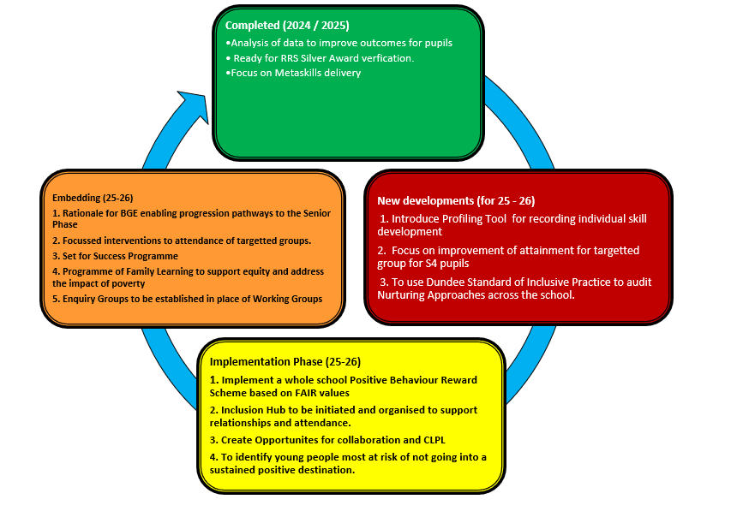


School Priorities 2025-26

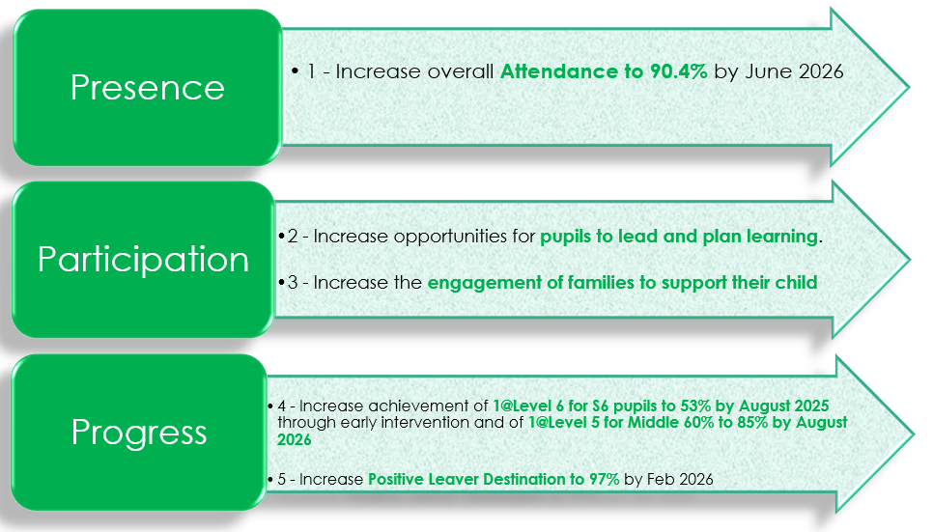

S3 Curriculum for Excellence

BGE Attainment Data 2021- 2022 (National Measure - percentages of S3 pupils achieving level 3 or better)

 | Reading | Writing | Talking & Listening | Numeracy
S3 (CFE Third Level) | 85% | 80% | 86% | 77%

From the figures above, 54% achieved level 4 in Reading, 53% in writing, 55% in Talking and Listening, and 45% achieved level 4 in Numeracy.

BGE Attainment Data 2022- 2023 (National Measure - percentages of S3 pupils achieving level 3 or better)
 | Reading | Writing | Talking & Listening | Numeracy
S3 (CFE Third Level) | 77% | 77% | 77% | 75%

From the figures above, 49% achieved level 4 in Reading, 49% in writing, 49% in Talking and Listening, and 39% achieved level 4 in Numeracy.

BGE Attainment Data 2023- 2024 (National Measure - percentages of S3 pupils achieving level 3 or better)
 | Reading | Writing | Talking & Listening | Numeracy
S3 (CFE Third Level) | 70% | 76% | 78% | 75%

From the figures above, 37% achieved level 4 in Reading, 45% in writing, 46% in Talking and Listening, and 55% achieved level 4 in Numeracy.

BGE Attainment Data 2024- 2025 (National Measure - percentages of S3 pupils achieving level 3 or better)
 |  | Reading | Writing | Talking & Listening | Numeracy
S3 (CFE Third Level) |  | 70% | 70% | 70% | 81%

From the figures above, 35% achieved level 4 in Reading, 36 % in writing, 35 % in Talking and Listening, and 37% achieved level 4 in Numeracy.

Local Benchmarking Measure: Literacy and Numeracy by SCQF Level (S4)
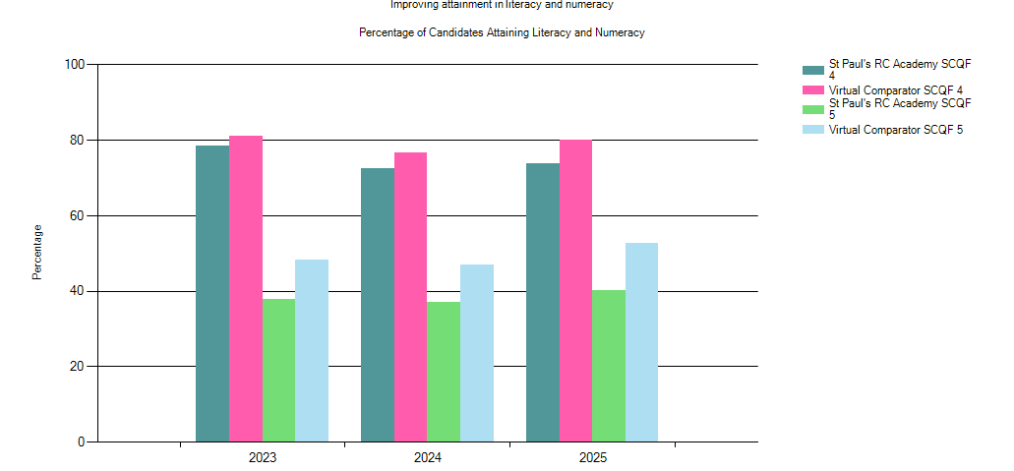

DisplayName | Year | % Level 4 Literacy and Numeracy | % Level 5 Literacy and Numeracy | Number in Cohort
St Paul's RC Academy | 2025 | 73.71 | 40.21 | 194
Virtual Comparator | 2025 | 80.15 | 52.73 | 1940
St Paul's RC Academy | 2024 | 72.40 | 36.98 | 192
Virtual Comparator | 2024 | 76.30 | 46.35 | 1920
St Paul's RC Academy | 2023 | 78.46 | 37.95 | 195
Virtual Comparator | 2023 | 81.44 | 48.31 | 1950

Local Benchmarking Measure: Literacy and Numeracy by SCQF Level (S5)

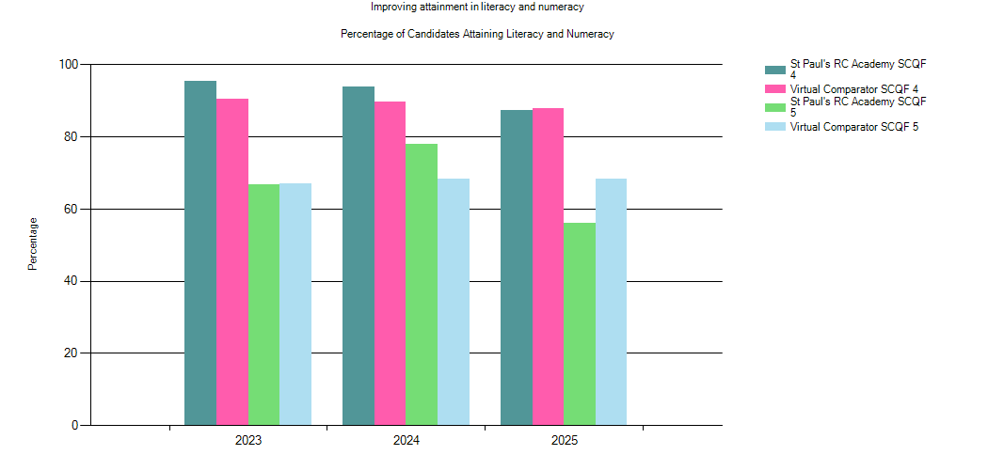

DisplayName | Year | % Level 4 Literacy and Numeracy | % Level 5 Literacy and Numeracy | Number in Cohort
St Paul’s RC Academy | 2025 | 87.23 | 56.03 | 141
Virtual Comparator | 2025 | 87.87 | 68.23 | 1410
St Paul's RC Academy | 2024 | 93.89 | 77.86 | 131
Virtual Comparator | 2024 | 90.08 | 69.16 | 1310
St Paul's RC Academy | 2023 | 95.37 | 66.67 | 108
Virtual Comparator | 2023 | 90.56 | 66.85 | 1080

Local Benchmarking Measure: Literacy and Numeracy by SCQF Level (S6)
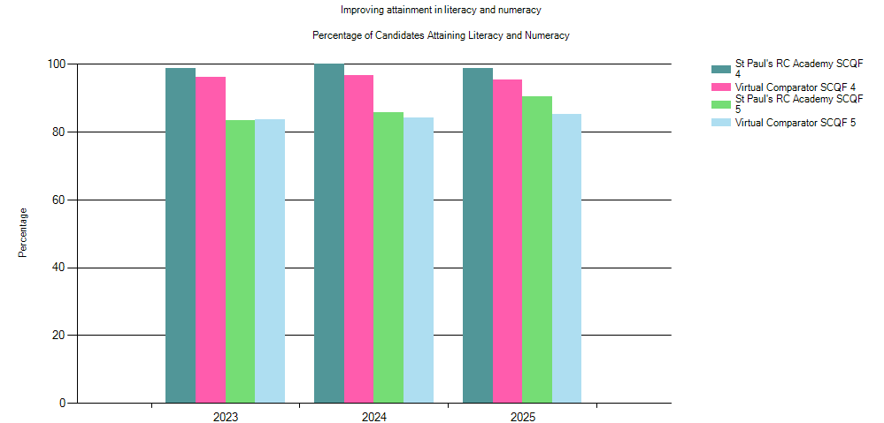

DisplayName | Year | % Level 4 Literacy and Numeracy | % Level 5 Literacy and Numeracy | Number in Cohort
St Paul’s RC Academy | 2025 | 98.80 | 90.36 | 83
Virtual Comparator | 2005 | 95.30 | 85.30 | 830
St Paul's RC Academy | 2024 | 100 | 85.71 | 70
Virtual Comparator | 2024 | 96.57 | 84.29 | 700
St Paul's RC Academy | 2023 | 98.73 | 83.54 | 79
Virtual Comparator | 2023 | 96.33 | 83.42 | 790

Local Benchmarking Measure: Leaver Initial Destinations

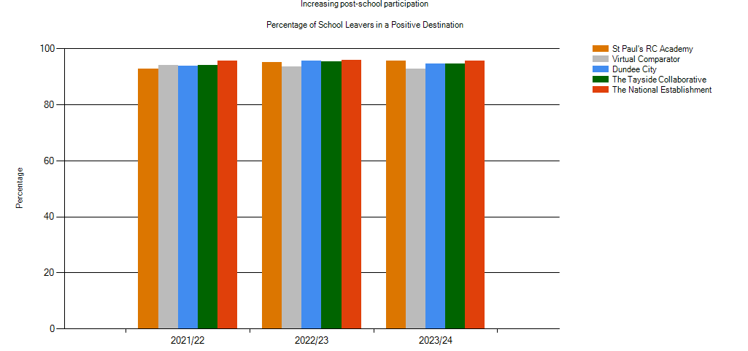

Establishment | Year | % of Schools Leavers in a Positive Destination | Number in Cohort
St Paul's RC Academy | 2023/24 | 95.76 | 165
Virtual Comparator | 2023/24 | 93.15 | 1650
Dundee City | 2023/24 | 94.76 | 1431
The Tayside Collaborative | 2023/24 | 94.54 | 4159
The National Establishment | 2023/24 | 95.71 | 55961
St Paul's RC Academy | 2022/23 | 95.27 | 169
Virtual Comparator | 2022/23 | 93.67 | 1690
Dundee City | 2022/23 | 95.56 | 1441
The Tayside Collaborative | 2022/23 | 95.34 | 3971
The National Establishment | 2022/23 | 95.87 | 54719
St Paul's RC Academy | 2021/22 | 92.78 | 180
Virtual Comparator | 2021/22 | 94.11 | 1800
Dundee City | 2021/22 | 93.9 | 1394
The Tayside Collaborative | 2021/22 | 94.05 | 4166
The National Establishment | 2021/22 | 95.74 | 55211

School Level Exclusion Rates (Incidents per 1000 pupils)
Establishment | 2019/20 | 2020/21 | 2021/22 | 2022/23 | 2023/24 | 2024/25
St Paul’s RC Academy | 18.9 | 19.2 | 27.7 | 45 | 54 | 68
Dundee City | 29.1 | 23.4 | 52.0 | 33.5 | 27.5

Attendance Rates
Establishment | 2019/20 | 2020/21 | 2021/22 | 2022/23 | 2023/24 | 2024/25
St Paul’s RC Academy | 87.8% | 87.4% | 83.9% | 83.6% | 84.8% | 86.4%
Dundee City | 88.0% | 90.4% | 85.9% | 88.5% | 89.0%

Study Support /Extra Curricular

St Paul’s Academy offers a wide range of opportunities to support study. This details some specific times which are offered by departments, but many other sessions are available on request from other subjects. Pupils should speak to their teacher if they would like extra help to agree a time for that support.

The current list of extra-curricular activities on offer can be seen in the table below.

